|  | **CAN THO UNIVERSITY SOFTWARE CENTER** |  |
| --- | --- | --- |
| **MEKONG DELTA - APTECH** |



**Ice-Cream Parlour**

**Design Document**

| **Faculty:** |  | Ms. Linh Ong Thi My |  |
| --- | --- | --- | --- |
| **Group No.:** |  | 3 |  |
| **Students:** |  | Student1320957  -Ngo Minh Khoa  Student1240316  -Doan Lan Anh  Student1321558  -Nguyen Manh Duc | Can Tho City,  02-2023 |
|  |  |  |  |
|  |  |  |  |

**DOCUMENTATION SECTION**



This is to certify that

Mr: Nguyen Manh Duc

Mr: Ngo Minh Khoa

Ms: Doan Lan Anh

Has successfully Designed &

Developed:……………….

Summited by: ……………

Date of Issue:…………….

Authorized Signature:…….

**PROBLEM DEFINITION**

Mr. “A” is the owner of the big Ice-cream parlor shop.He is famous for the taste and quality of the product they provide. .As the number of customers is increasing, the store's branches are constantly increasing. However, Mr. “A” wants the Ice Cream Brand to be more famous, develop nationwide, create profit value by selling Mr. “A” Ice Cream Recipe, selling Mr. “A” Ice Cream Teaching Book, Update more recipes New ice cream from Community. To popularize it more the owner of the company has decided to go for making the website of his shop. Understanding that Need, Our Team approached to create a website for Mr. “A”.

When users access the Ice cream parlor shop website, users will read detailed information about Ice Cream Brand, Some Free Ice Cream Recipes, Information about Brand Owner, contact information Contact, send Comments, send questions.

Users can buy Ice Cream Brands Ice Cream making books and pay online with Card without Membership registration.

Users can submit their own Ice Cream Recipes to the Website, if they meet the requirements, they will be paid a commission.

If the user has a need to learn the Ice Cream Chain's own Ice Cream Recipes, the User can register to become a Member of the Website and there is a fee, details: fifteen dollars per month or one hundred and fifty dollars per year . As a member of the Website, the user will have full enough functions for users on the website as listed above.

Website management representative of the Mr. “A” Ice Cream shop chain, will be granted Website Management rights through an Admin account, and have a separate Page with the following functions:

* Manage and update the list of Ice Cream Recipes, New Ice Cream Recipes from users;

* Manage Member List, User List with their Payment Details; Manage and update order status Buy Ice Cream Learning Book;

* Manage and respond to comments, questions of users and members.

**CUSTOMER REQUIREMENTS SPECIFICATION (CRS)**

**Name of Project**: The Ice-Cream Parlor Shop Website

**Actor Description**

| **No.** | **Actor** | **Use Case** | **Description** |
| --- | --- | --- | --- |
| 1 | Admin | Login | This module allows Administrator to login |
| Manage products | This module allow Administrator manage information of product consist of add new product, update product, delete product,view product.  Product as: Ice Cream Recipe and Book |
| View Order | This module allows the Admin to view the order of customers. |
| Manage  Feedback | This module allows Administrator to view feedback and comment back |
| Manage  Categories | This module allows administrators to manage information of Categories consisting of add new Categories, update Categories , delete Categories ,view Categories .  Product as: Ice Cream Recipe |
| Manage Payment Method | This module allows Administrator to manage information of payment method consist of add new payment method, update information of payment method, delete payment method, view payment method.  Product as: Ice Cream Recipe and Book |
| Manage Member | This module allows the Administrator to manage information of user consist of add new admin, update the information of admin, delete admin, view admin, view customer, update status customer |
| Manage Ice Cream Recipe From Customer | This module allow Administrator manage information of Recipe Ice Cream from Customer consist of add new Ice Cream Recipe, update New Ice Cream Recipe, delete Ice Cream Recipe ,check status for new Ice Cream Recipe and pay bonus for Customer. |
| Images | This module allow Administrator manage information of Newsconsist of add new Images, update image, delete image,view image |
| 2 | Customer | View system | This module allows Customer to view system |
| Login | This module allows Customer to login in |
| View Product | This module allows Customer to View products: Recipe Ice Cream and Book |
| Cancel Order  Book | This module allows Customer to cancel Order Book online |
| Order Book | This module allows Customer to Order Book online |
| Pay bills online | This module allows Customer to pay bills online |
| View order history | This module allows Customer to View order history after customer ordered |
| Send Feedback | This module allows Customer to send feedbacks |
| Send Comment Ice Cream Recipe | This module allows Customer to Send comment ice cream recipe |
| 3 | Guest | View system | This module allows Guest to view system |
| Register user | This module allows Guest register user and chart fee |
| View Product | This module allows Guest to view Product as common Ice Cream Recipe and Book |
| Search product | This module allows Guest to search Products as: Book, Common Ice Cream Recipes |
| Order Book | This module allows Guest to Order Book online |
| Pay bills online | This module allows Guest to pay bills online |
| View order history | This module allows Guest to View order history after Them ordered |
|  | Send Feedback | This module allows Guest to send feedbacks |
| Send Ice Cream  Recipe | This module allows Guest to Send ice cream recipe |

**Inputs provided by the Client:**

1. **Manage Admin: T**his module allows Administrators to log in and change password admin.

**1.1. Login**

* Purpose: This function allows Administrators to log in
* Inputs: id of admin, password
* Outputs: Success message

**1.2. Change password**

* Purpose: This function allows Admin to change password..
* Inputs: id, password of admin
* Outputs: Password information of Administrator is updated to table of database

1. **Manage Members:** TThis module allows the Administrator to manage information of users consisting of adding new admin, update the information of admin, delete admin, view information Customer,update customer status.

**2.1. Add of Admin**

* Purpose: This function allows Admin to add new information.
* Inputs: ID, Password of Admin.
* Outputs: New information of admin is added to the table of database.

**2.2. Update of Admin**

* Purpose: This function allows Admin to update new information.
* Inputs: ID, Password of Admin.
* Outputs: Information of administrator is updated to the database.

**2.3. Delete of Admin**

* Purpose: This function allows Admin to delete admin.
* Inputs: ID of Admin.
* Outputs: Information of admin is deleted to the table of the database.

**2.4. View Information of Customers and update customer status:**

* Purpose: This function allows Admin to view Information of information Customer,update customer status.
* Inputs: ID, Username, Address, Email, Phone, Type, Birthday of customer.
* Outputs: All of Customers information is displayed on the datatable.

1. **Manage products:** This module allow Administrator manage information of product consist of add new product, update product, delete product,view product.

Product as: Ice Cream Recipe and Book

**3.1. Add Product**

* Purpose: This function allows Admin to add new product information.
* Inputs: ID, Category of recipe, Name, Text, Status, Price, Images, status.
* Outputs: New Ice Cream Recipe information is added to the database table.

**3.2. Update Product**

* Purpose: This function allows Admin to update new Ice Cream Recipe information.
* Inputs: ID, Category of recipe, Name, Text, Status, Price, Images, status.
* Outputs: Update Ice Cream Recipe information is added to the database table.

**3.3. Delete Product**

* Purpose: This function allows Admin to delete Ice Cream Recipe.
* Inputs: ID of recipe
* Outputs: The product is removed from the database table.

**4. Manage Ice Cream Recipe From Customer:** This module allows the Administrator to manage information of Recipe Ice Cream from Customer consisting of View Ice Cream Recipe, update New Ice Cream Recipe, delete Ice Cream Recipe ,check status for new Ice Cream Recipe and pay bonus for Customer.

**4.1. View Information of Ice Cream Recipes From Customers:**

* Purpose: This function allows Admin to view Information of Ice Cream Recipes From Customers.
* Inputs: ID of recipe ,Username of customer, Name of recipe, Text of recipe, Quantity of recipe, Images of recipe
* Outputs: All feedback information is displayed on the datatable.

**4.2. Update Ice Cream Recipe From Customer:**

* Purpose: This function allows Admin to update new Ice Cream Recipes from Customer information.
* Input: ID of recipe ,Category of recipe, Name of recipe, Text of recipe, Price of recipe,Status of recipe, Images of recipe, Bonus of recipe.
* Outputs: Update Ice Cream Recipe information is added to the database table.

**4.3. Delete Ice Cream Recipe From Customer:**

* Purpose: This function allows Admin to delete Ice Cream Recipe from Customer.
* Inputs: ID of recipe
* Outputs: The Ice Cream Recipe is removed from the database table.

**5. Manage Categories of Ice Cream Recipe :** This module allows administrators to manage information of Categories consisting of add new Categories, update Categories , delete Categories ,view Categories. Product as: Ice Cream Recipe

**5.1. Add Categories of Ice Cream Recipe :**

* Purpose: This function allows Admin to add new categories information.
* Inputs: ID, Name, Status of category
* Outputs: New categories information is added to the database table.

**5.2. Update Categories of Ice Cream Recipe :**

* Purpose: This function allows Admin to update new categories information.
* Inputs: ID, Name, Status of category
* Outputs: Update categories information is added to the database table.

**5.3. Delete Categories of Ice Cream Recipe :**

* Purpose: This function allows Admin to delete categories.
* Inputs: ID of category
* Outputs: The categories are removed from the database table.

**6. Manage Feedback:** This module allows Administrator to view feedback and comment back

**6.1. View Feedback**

* Purpose: This function allows Admin to view feedback kind information.
* Inputs: ID of feedback
* Outputs: All feedback information is displayed on the datatable

**6.2. Common Feedback**

* Purpose: This function allows Admin to add new information and comment on feedback.
* Inputs: ID of feedback, ID of customer, Name of feedback, Email of feedback, Phone of feedback, Type of feedback, Text of feedback
* Outputs: Add comment feedback information to the database table.

**7. Send feedback:** This module allows Customer and Guest to send feedbacks

* Purpose: This function allows Customer and Guest to send feedbacks
* Inputs: ID of feedback, ID of customer, Name of feedback, Email of feedback, Phone of feedback, Type of feedback, Text of feedback
* Outputs: New information of feedback is added to the table of the database.

**8. Send Comment Ice Cream Recipe:** This module allows Customer and Guest to Send comment ice cream recipe

**8.1. Add Comment Ice Cream Recipe:**

* Purpose: This function allows Customer and Guest to add a new Ice Cream Recipe.
* Inputs: ID of recipe, Username of customer, Name of recipe, Text of recipe, Quantity of recipe, Images of recipe
* Outputs: New comment Ice Cream Recipe information is added to the database

**8.2. Update Comment Ice Cream Recipe:**

* Purpose: This function allows Customer and Guest to update a new Ice Cream Recipe.
* Inputs: ID of recipe, Username of customer, Name of recipe, Text of recipe, Quantity of recipe, Images of recipe
* Outputs: Update a new Ice Cream Recipe information is added to the database.

**9. View Product:** This module allows Customer and Guest to View products: Recipe Ice Cream and Book.

* Purpose: This function allows Customer and Guest to View products: Recipe Ice Cream and Book.
* Input: ID of recipe, Category of recipe ,Name of recipe, Text of recipe, Status of recipe,Price of recipe, Images of recipe, status of recipe.
* Output: All of Product information is displayed on the datatable

**10. Order Book:** This module allows Customer and Guest to Order Book online

* Purpose: This function allows Customers and Guests to Order Book online.
* Inputs: ID of order, ID of book, ID of customer, ID of Payment, Username of customer, Price of order, Address of customer, Status of order, Contact details of order.
* Outputs: New information of order is added to the table of the database.

**11. Cancer Order:** This module allows Customer and Guest to cancel order

* Purpose: This function allows Customers and Guests to cancel orders.
* Inputs: ID, Status of order
* Outputs: Information of order is updated to the table of the database.

**12. View Order:** This module allows Admin to view the order of Customers and Guests.

* Purpose: This function allows Admin to view order information of Customers and Guests.
* Inputs: Id of order.
* Outputs: All order information is displayed on the datatable.

**13. View order history:** This module allows Customer and Guest to View order history after customer ordered

* Purpose: This function allows to view order history information of Customers and Guests.
* Inputs: ID of order, ID of Customer.
* Outputs: Order information of Customers and Guests is displayed on the datatable.

**14. Register User:** This module allows Guest register users.

* Purpose: This function allows Guest register users.
* Inputs: ID, Username, Password, Address, Email, Phone, Type, Birthday of customer.
* Outputs: Order information of Customers and Guests is displayed on the datatable.

**15. Login of Customer:**  This module allows Login of Customer.

* Purpose: This function allows Login of Customer.
* Inputs: Username, Password of customer.
* Outputs: Go to the interface appropriate for each user function.

**16. Manage Payment Method:** This module allows the Administrator to manage information of payment methods consisting of add new payment method, update information of payment method, delete payment method, view payment method.

Product as: Ice Cream Recipe and Book.

**16.1. Add new payment method**

* Purpose: This function allows the Admin to add new information about payment methods.
* Inputs: ID, NumberCode, NameViewer, Price,Time of payment methods.
* Outputs: New information of payment method is added to the table of the database.

**16.2. Update payment method**

* Purpose: This function allows the Admin to Update new information about payment methods.
* Inputs: ID, NumberCode, NameViewer, Price,Time of payment methods.
* Outputs: Information of payment method is updated to the database.

**16.3. Delete payment method**

* Purpose: This function allows Admin to delete payment methods.
* Inputs: ID of payment methods.
* Outputs: Information of payment method is deleted to the table of the database.

**Ice Cream Parlour Use Case Diagram**

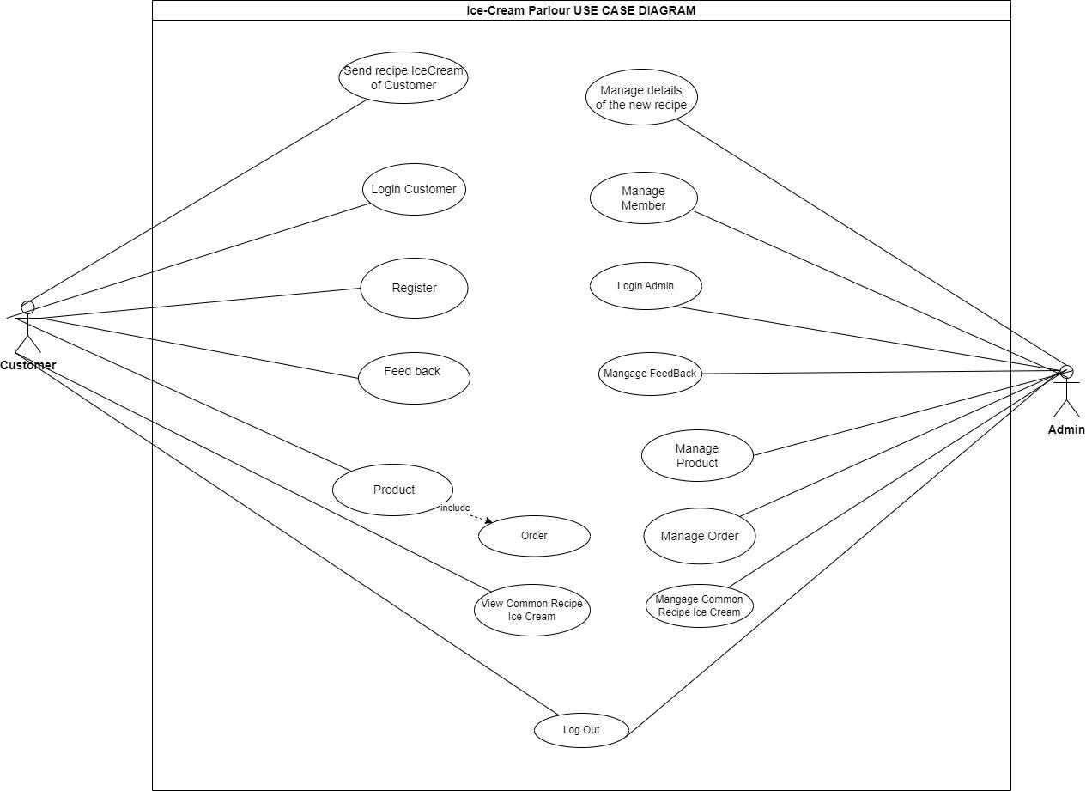

**Order :**

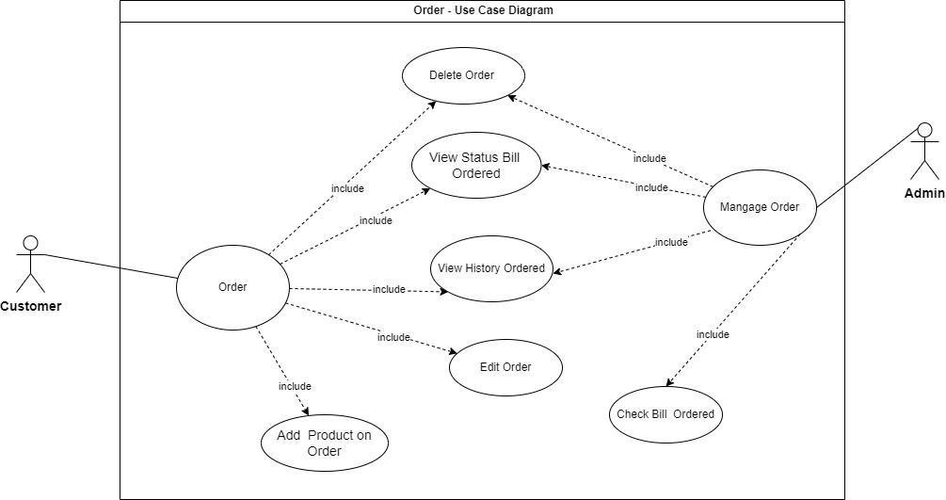

**Product**

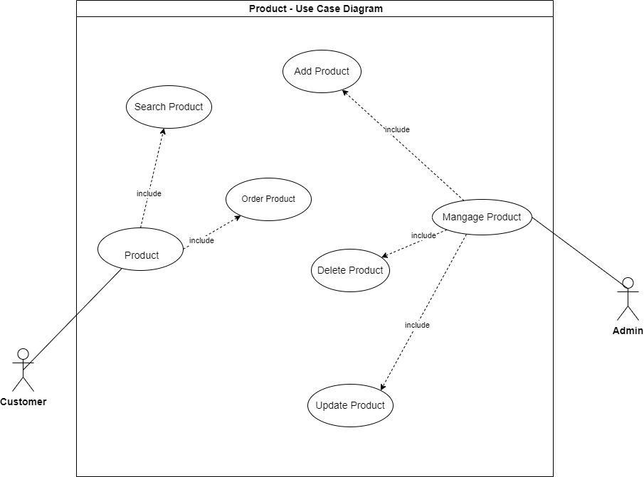

**Feedback**

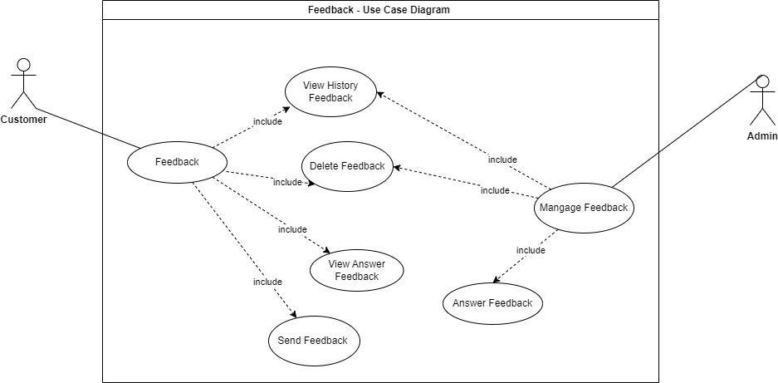

**Hardware and Software required for implementing the project**

|  | **Server** | **Client** |
| --- | --- | --- |
| **Hardware** | * **CPU: Intel Core i5 or higher.** * **RAM: 4GB or higher** * **HDD or SSD: 512GB hard disk space or higher** | * **CPU: Intel Core i3 or higher.** * **RAM: 4GB or higher** * **HDD or SSD: 256GB hard disk space or higher** |
| **Software** | * **Visual Studio .Net / ASP 2022 (.Net framework 4.7.2)** * **SQL Server 2022** * **IIS server** * **Java Virtual Machine/ J2EE server** | * **Browser: Chrome,Firefox,Microsoft Edge,Opera,Safari** |
| **Additional**  **Technology** |  | |

**ARCHITECTURE AND DESIGN OF THE PROJECT**

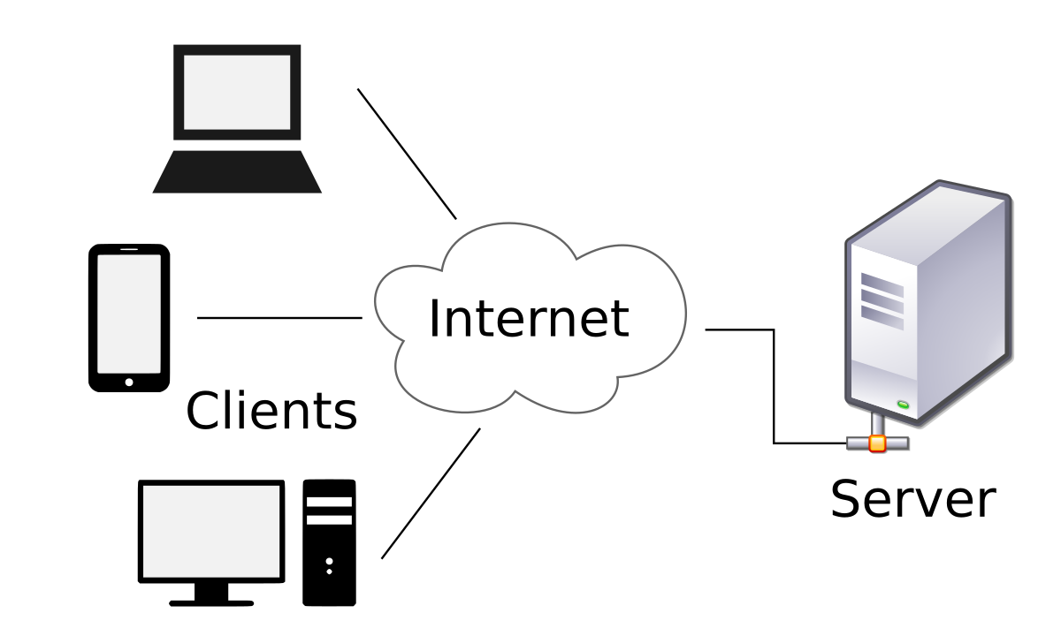

**Site Map**

Home Page

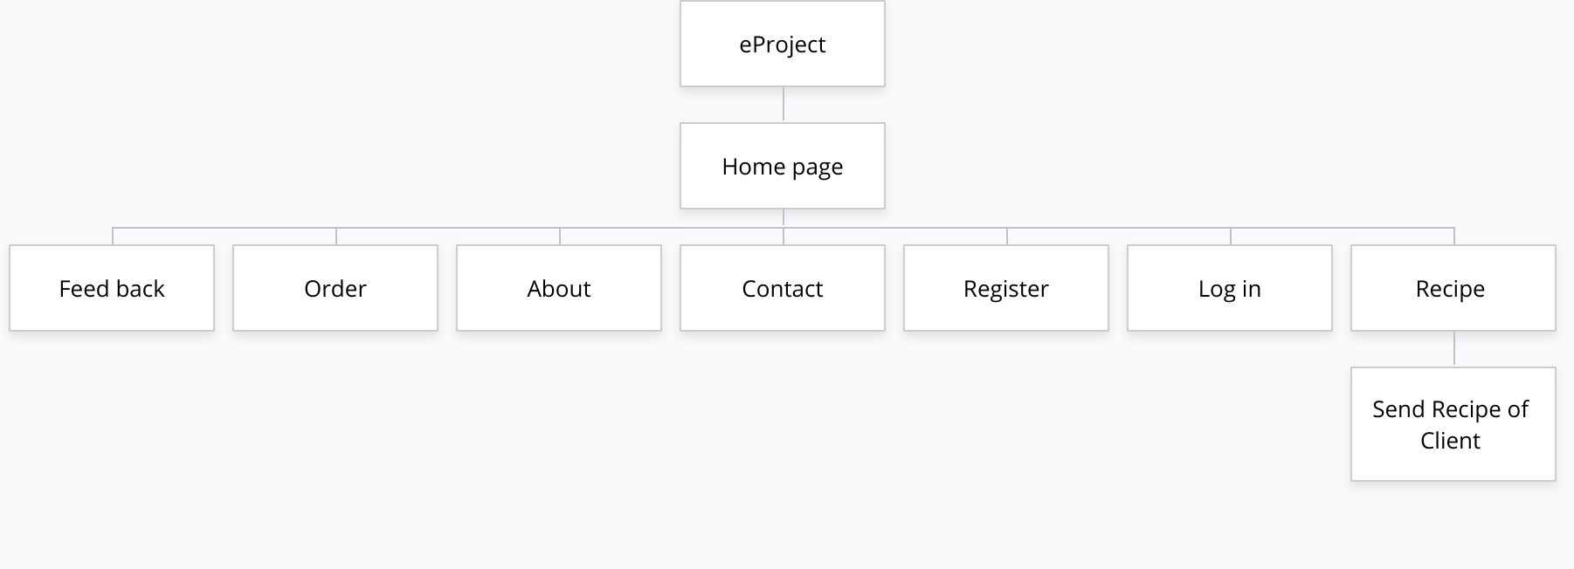

Admin Page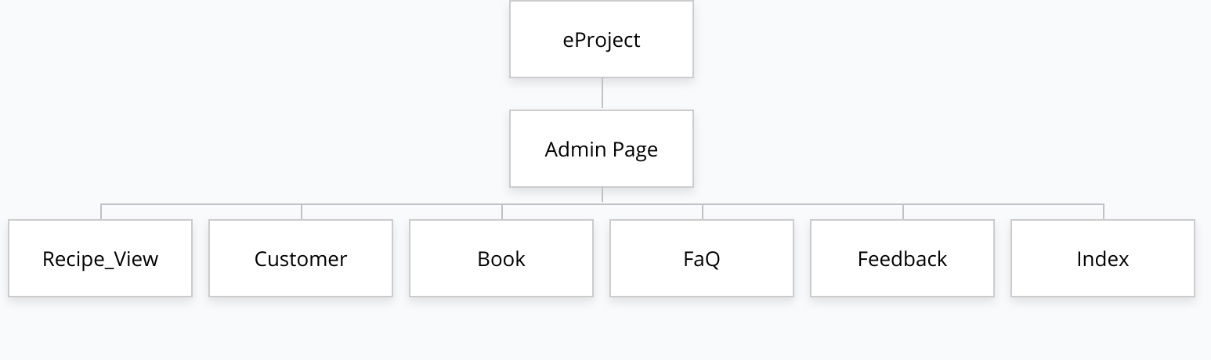

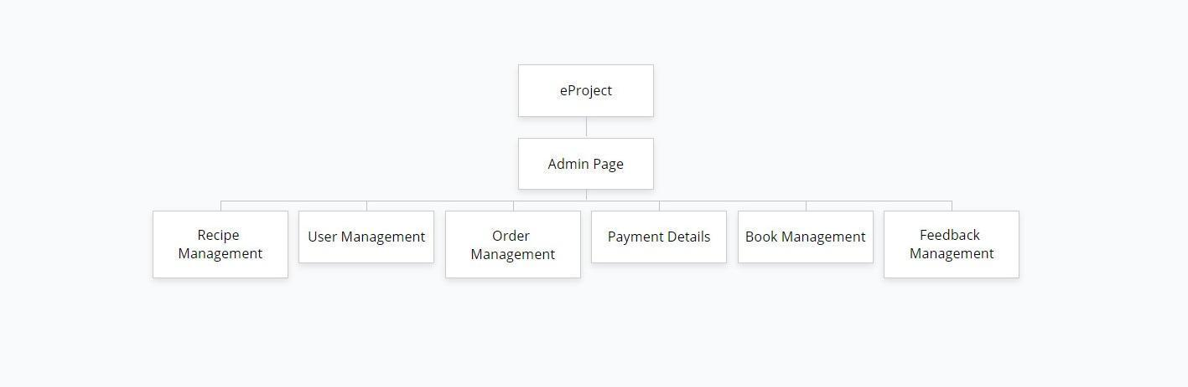

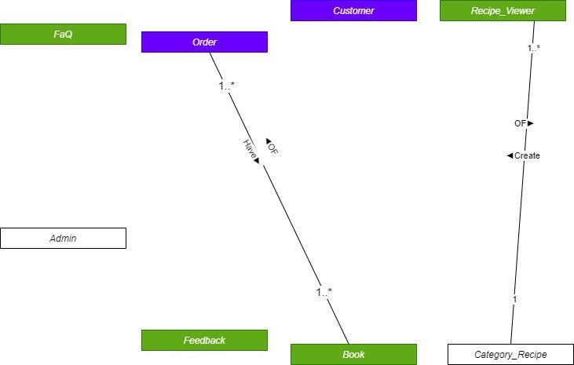

**Class Diagram**

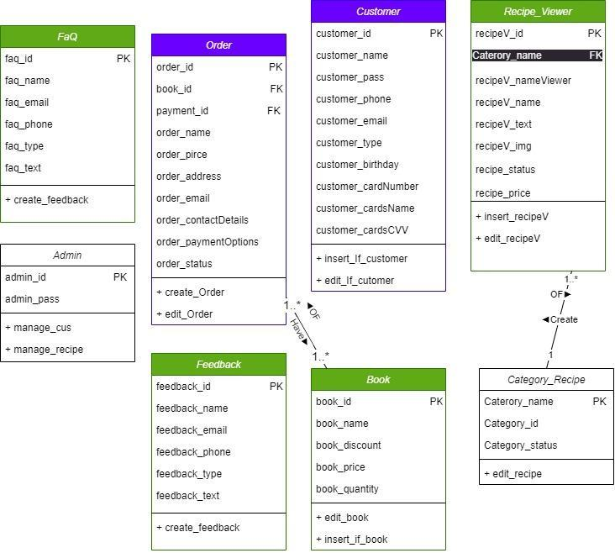

**Database design/Structure**

Database Structure of different Stables is given in following sections:

**Table design:**

| **Admin** | | | |
| --- | --- | --- | --- |
| **Field Name** | **Data Type** | **Constraint**  **(Primary Key, Foreign Key, Identity, Not Null,...)** | **Description** |
| admin_id | int | Primary key, identity | Stores the identification  code of admin |
| admin_pass | varchar(50) | Not null | Stores the password of admin |

| **Customer** | | | |
| --- | --- | --- | --- |
| **Field Name** | **Data Type** | **Constraint**  **(Primary Key, Foreign Key, Identity, Not Null,...)** | **Description** |
| customer_id | int | Primary key, identity | Stores the identification  code of customer |
| customer_name | varchar(50) | Not null | Stores the username of customer |
| customer_address | varchar(50) | Not null | Stores the address  of customer |
| customer_email | varchar(50) | Not null | Stores the email  of customer |
| customer_pass | varchar(16) | Not null | Stores the password  of customer |
| customer_phone | int | Not null | Stores the phone  of customer |
| customer_type | int | Not null | Stores the type  of customer |
| customer_birthday | date | Not null | Stores the birthday  of customer |
| customer_cardNumber | int | Not null | Stores the Card Number |
| customer_cardsName | vachar(50) | Not null | Stores the Card Number |
| customer_cardCVV | int | Not null | Stores the CVV |

| **Recipe_Viewer** | | | |
| --- | --- | --- | --- |
| **Field Name** | **Data Type** | **Constraint**  **(Primary Key, Foreign Key, Identity, Not Null,...)** | **Description** |
| recipeV_id | int | Primary key, identity | Stores the ID  of recipe |
| caterory_name | varchar(10) | FK | Stores the FK category  of recipe |
| recipeV_nameViewer | varchar(50) | Not null | Stores the name  of recipe |
| recipeV_text | varchar(500) | Not null | Stores the text  of recipe |
| status | int | Not Null | Stores the status  of recipe.  True = approved  False = not approved yet |
| recipeV_price | int | Not Null | Stores the price  of recipe |
| recipeV_img | varchar(10) | Not Null | Stores the img  of recipe |
| bonus | varchar(10) | not null | Stores the bonus  of recipe |

| **Category_Recipe** | | | |
| --- | --- | --- | --- |
| **Field Name** | **Data Type** | **Constraint**  **(Primary Key, Foreign Key, Identity, Not Null,...)** | **Description** |
| category_ id | int | Primary key, identity | Stores the ID  of category |
| caterory_name | varchar(10) | PK | Stores the Name of category |
| category_status | int | Not Null | Stores the status  of category  True = approved  False = not approved yet |

| **Book** | | | |
| --- | --- | --- | --- |
| **Field Name** | **Data Type** | **Constraint**  **(Primary Key, Foreign Key, Identity, Not Null,...)** | **Description** |
| book_id | int | Primary key, identity | Stores the ID  of book |
| book_name | varchar(50) | Not null | Stores the name  of book |
| book_discount | varchar(10) | Not null | Stores the discount  of book |
| book_price | int | Not null | Stores the price  of book |
| book_quantity | int | Not null | Stores the quantity  of book |

| **Order** | | | |
| --- | --- | --- | --- |
| **Field Name** | **Data Type** | **Constraint**  **(Primary Key, Foreign Key, Identity, Not Null,...)** | **Description** |
| order_id | int | Primary key, identity | Stores the ID  of order |
| book_id | int | PK | Stores the ID  of book |
| payment_id | int | PK | Stores the ID  of payment |
| order_name | varchar(50) | Not null | Stores the username of customer |
| order_price | int | Not null | Stores the price  of order |
| order_address | varchar(50) | Not null | Stores the address  of customer |
| order_email | varchar(50) | Not null | Stores the email  of customer |
| order_contactDetails | varchar(10) | Not null | Stores the contact  details of order |
| order_status | int | Not Null | Stores the status  of order  True = approved  False = not approved yet |

| **FaQ** | | | |
| --- | --- | --- | --- |
| **Field Name** | **Data Type** | **Constraint**  **(Primary Key, Foreign Key, Identity, Not Null,...)** | **Description** |
| faq_id | int | Primary key, identity | Stores the ID  of FaQ |
| faq_name | varchar(50) | Not null | Stores the name  of FaQ |
| faq_email | varchar(50) | Not null | Stores the email  of FaQ |
| faq_phone | varchar(10) | Not null | Stores the phone  of FaQ |
| faq_type | int | Not Null | Stores the type  of FaQ |
| faq_text | varchar(500) | Not Null | Stores the text  of FaQ |

| **Feedback** | | | |
| --- | --- | --- | --- |
| **Field Name** | **Data Type** | **Constraint**  **(Primary Key, Foreign Key, Identity, Not Null,...)** | **Description** |
| feedback_id | int | Primary key, identity | Stores the ID  of feedback |
| customer_id | int | FK | Store the username  of customer |
| feedback_name | varchar(50) | Not null | Stores the name  of feedback |
| feedback_email | varchar(50) | Not null | Stores the email  of feedback |
| feedback_phone | varchar(10) | Not null | Stores the phone  of feedback |
| feedback_type | int | Not Null | Stores the type  of feedback |
| feedback_text | varchar(500) | Not Null | Stores the text  of feedback |

**ACTIVITY DIAGRAM**

**Register :**

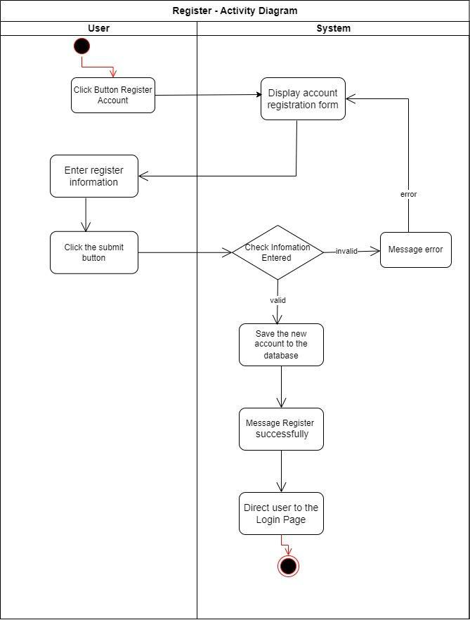

**Login :**

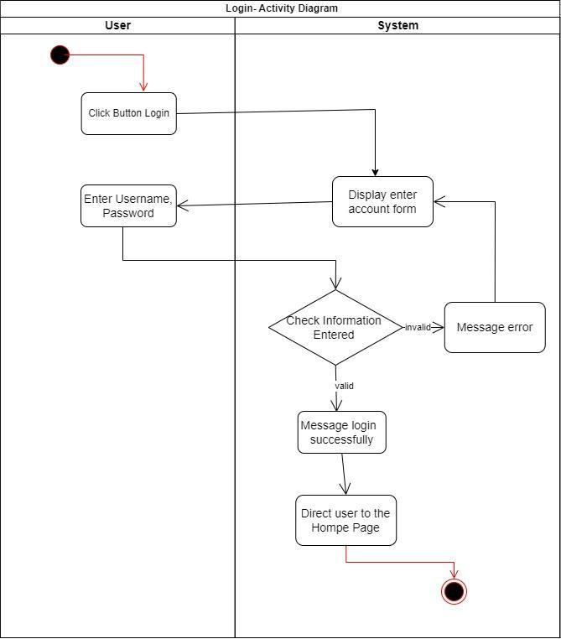

**Chart Fee Register**

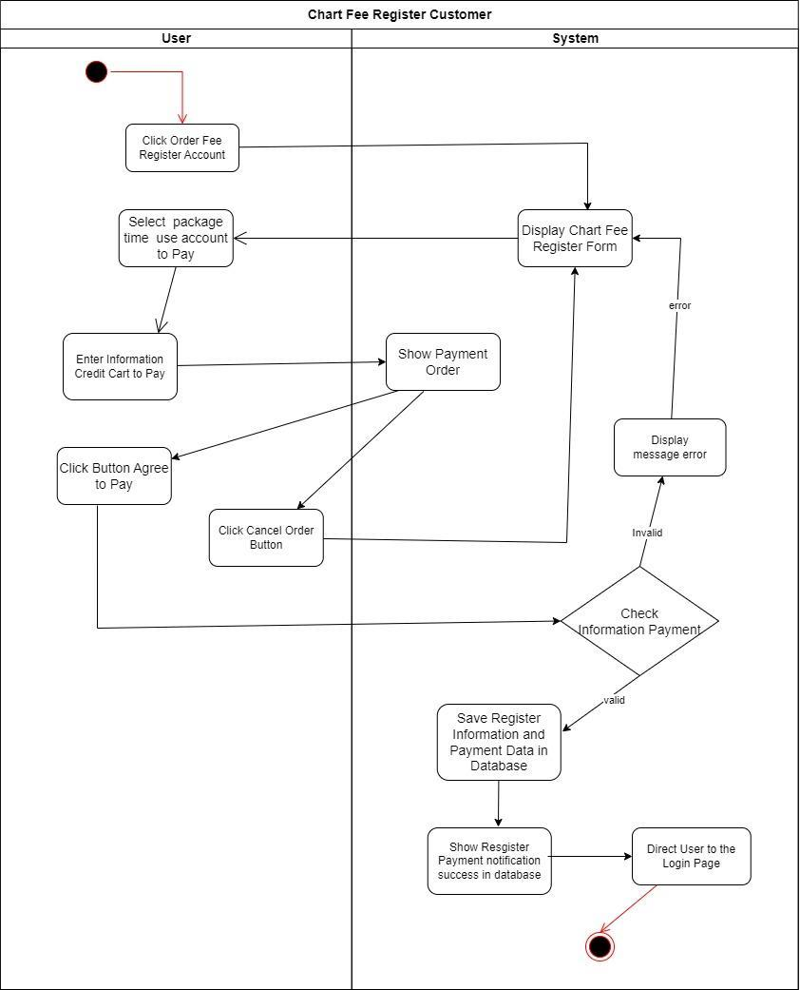

**Change Password:**

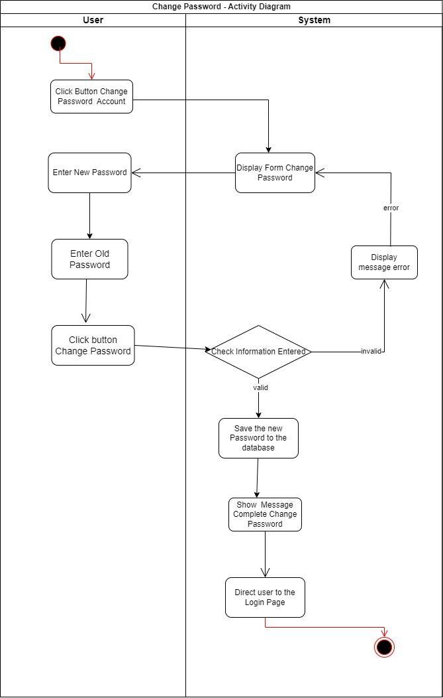

**Log out**

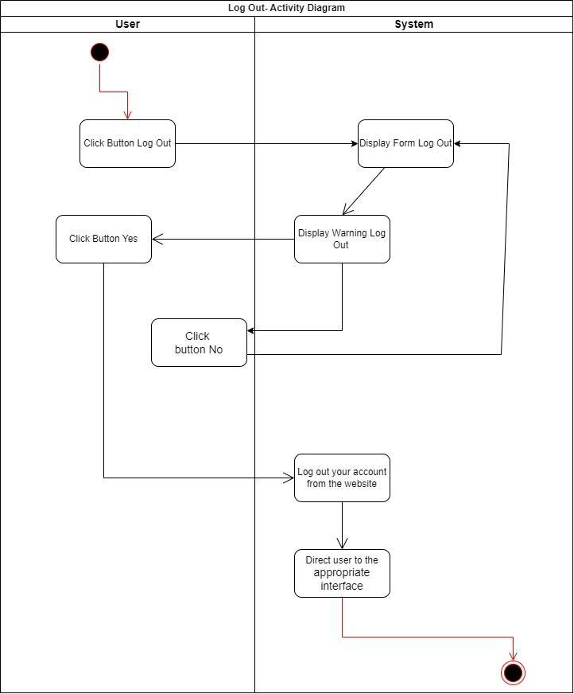

**Customer Add New Recipe Ice Cream**

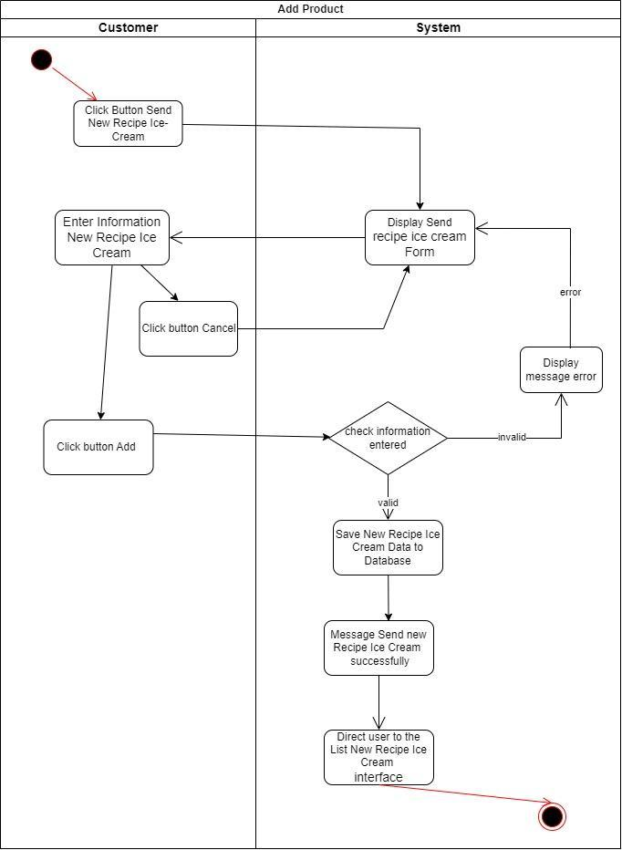

**Admin, Customer Add Order:**

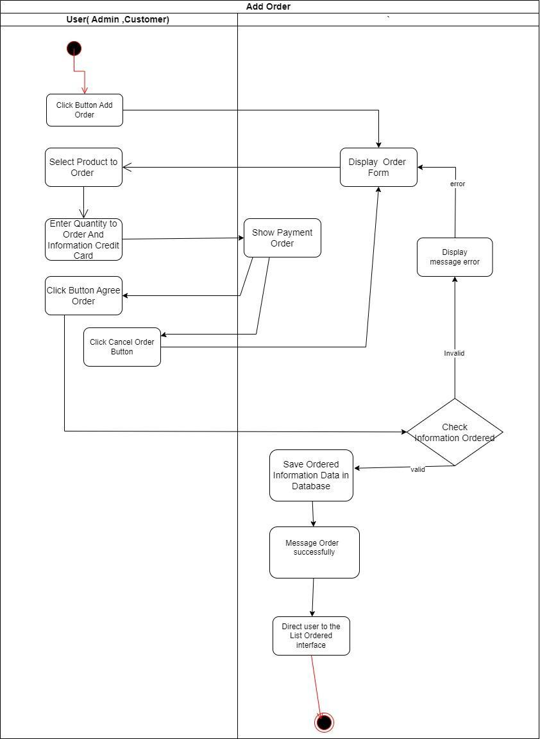

**Admin, Customer Delete Order:**

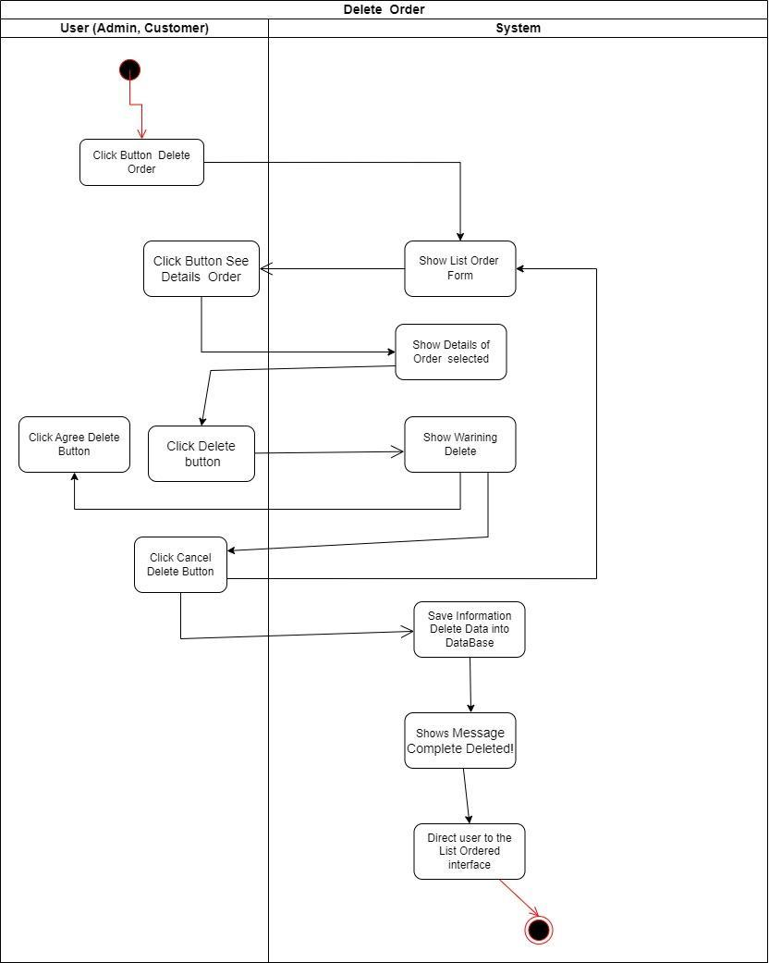

**View History Order:**

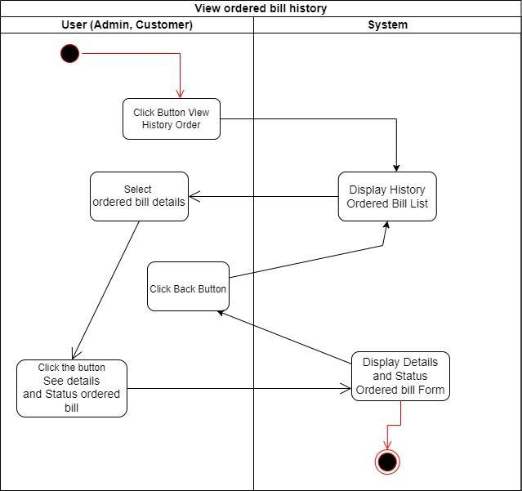

**Admin Update Order:**

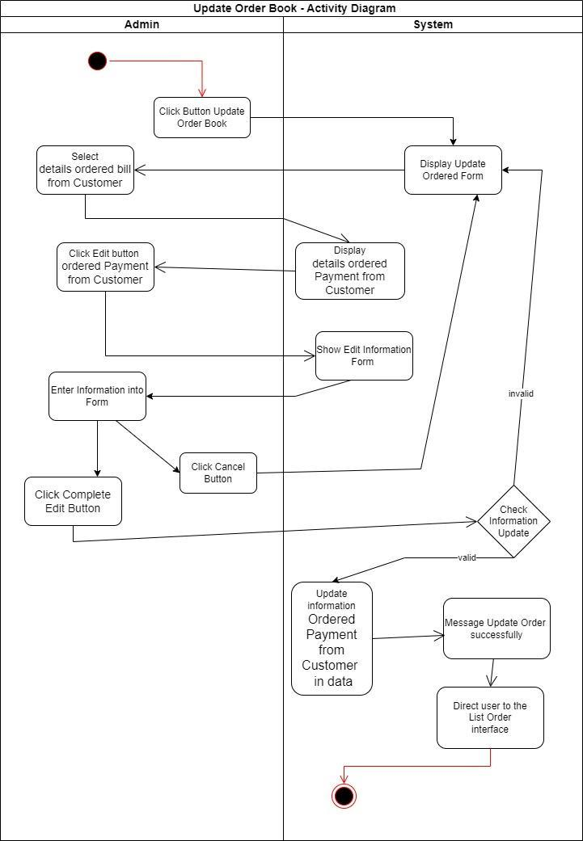

**Admin Check and Export Order Book**

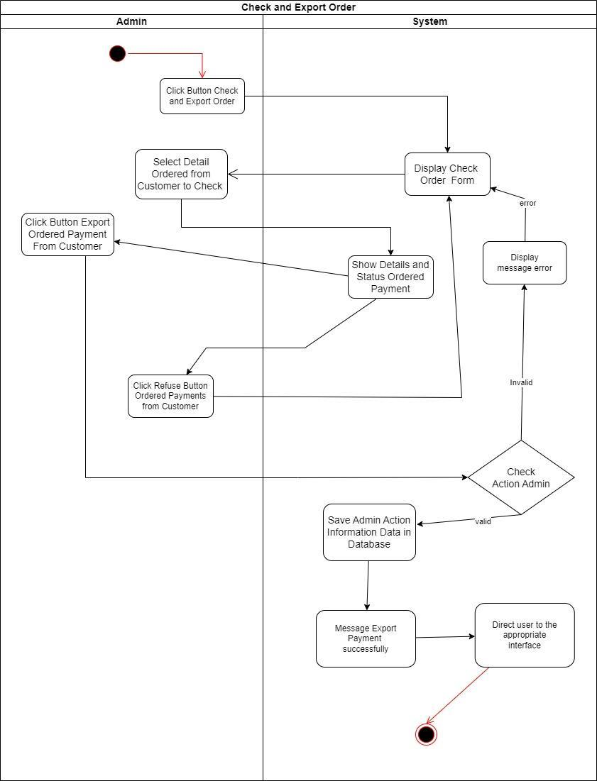

**Admin, Customer Update Order Book:**

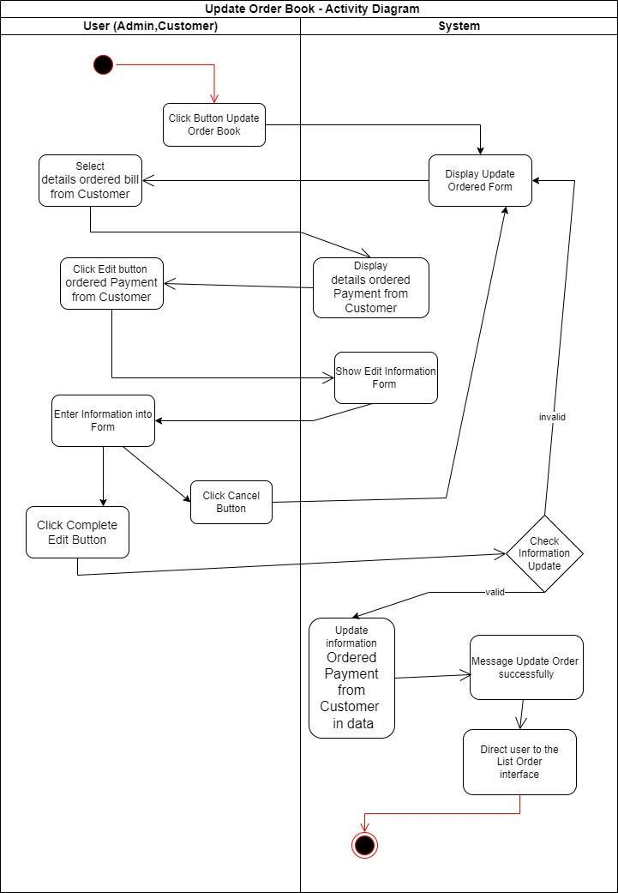

**Admin Add Product:**

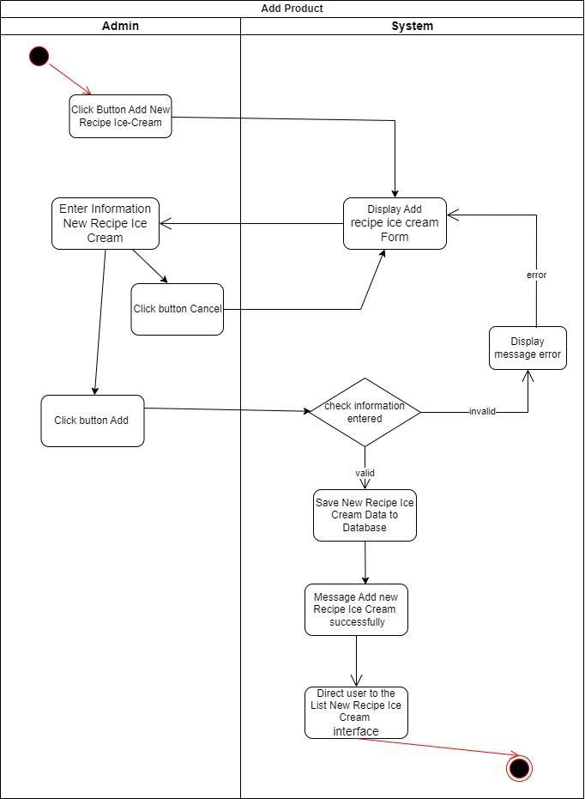

**Admin Update Product:**

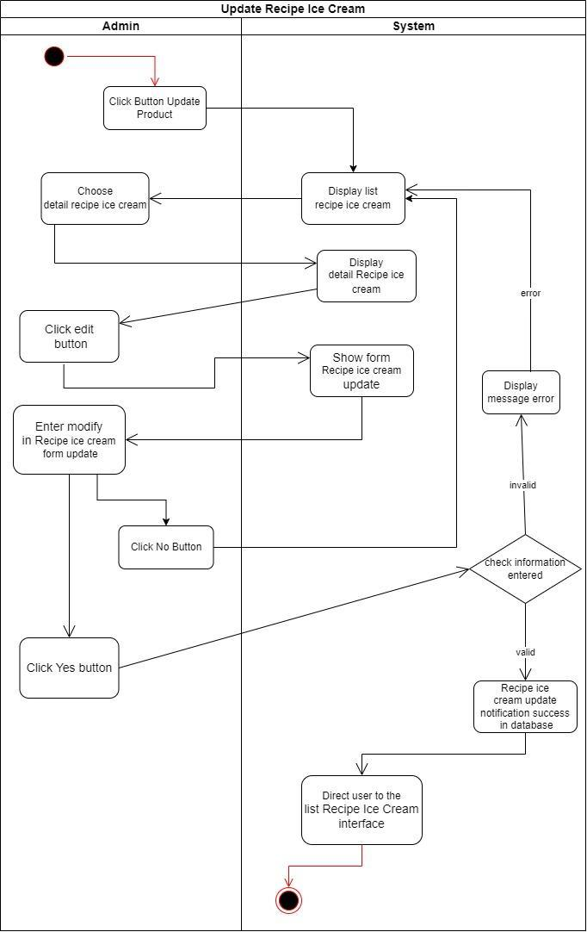

**Admin ,Customer Delete Product:**

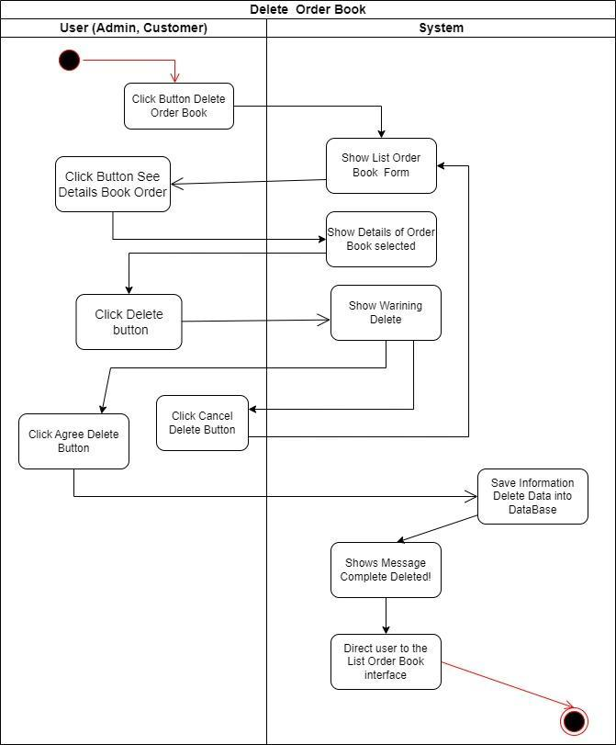

**Customer Add Feedback:**

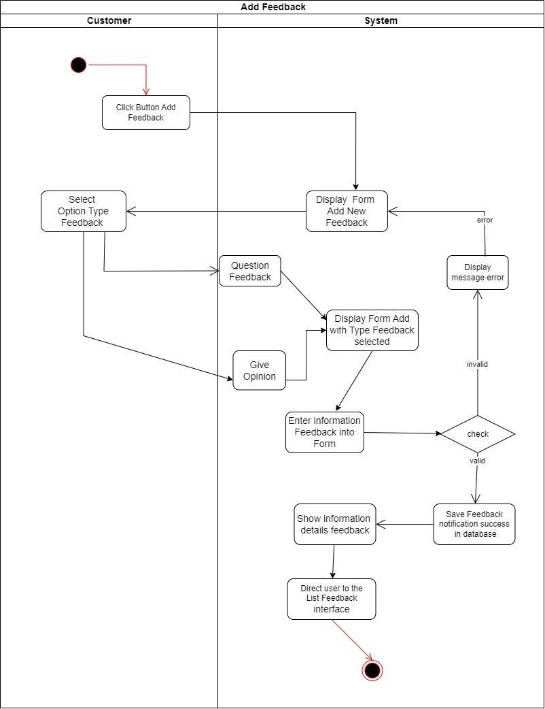

**Customer Update Feedback:**

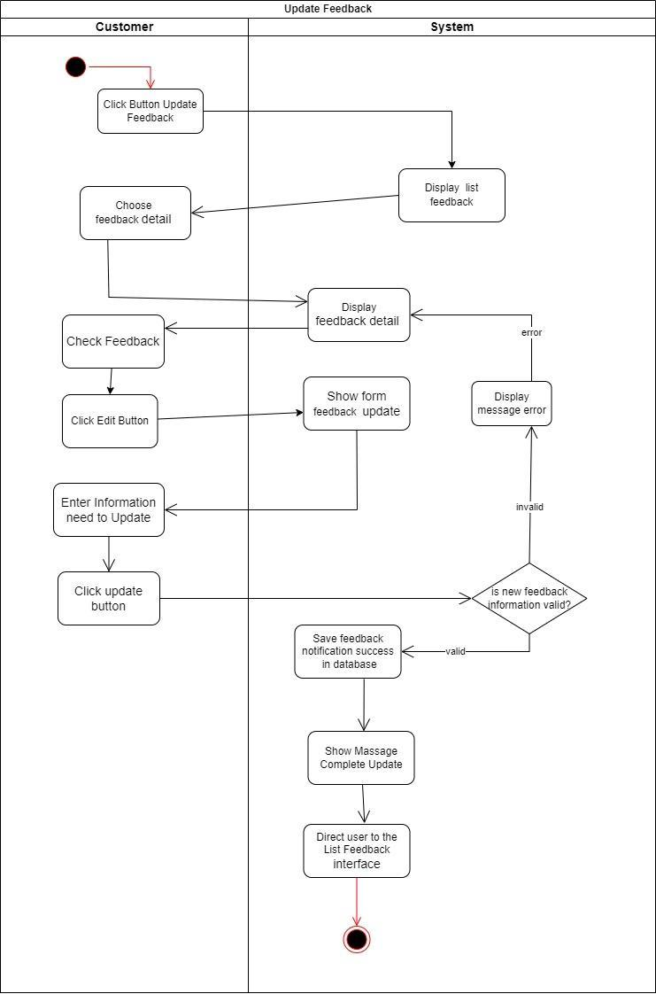

**Admin Delete Feedback:**

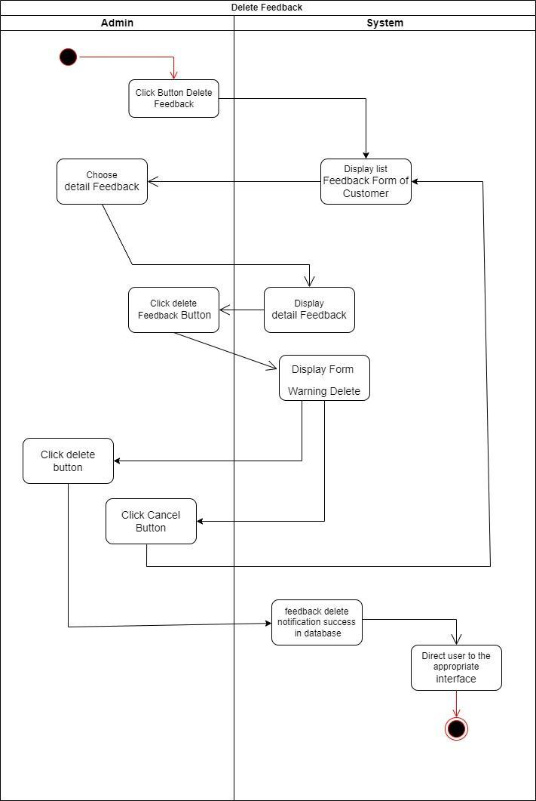

**Admin Answer Feedback:**

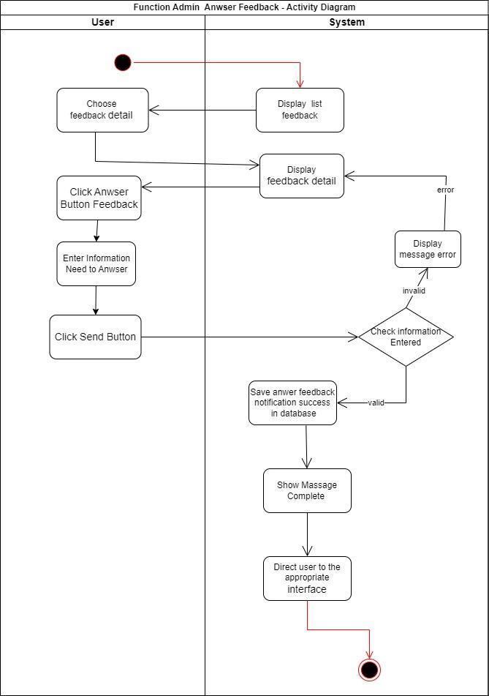

**Manage Book Activity Diagram:**

**Admin Add Book:**

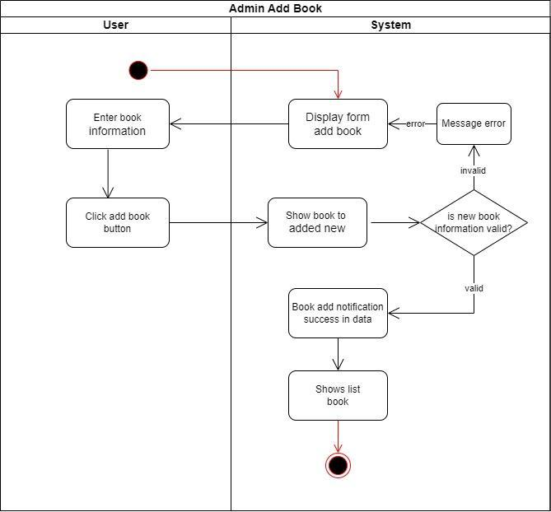

**Admin Update Book:**

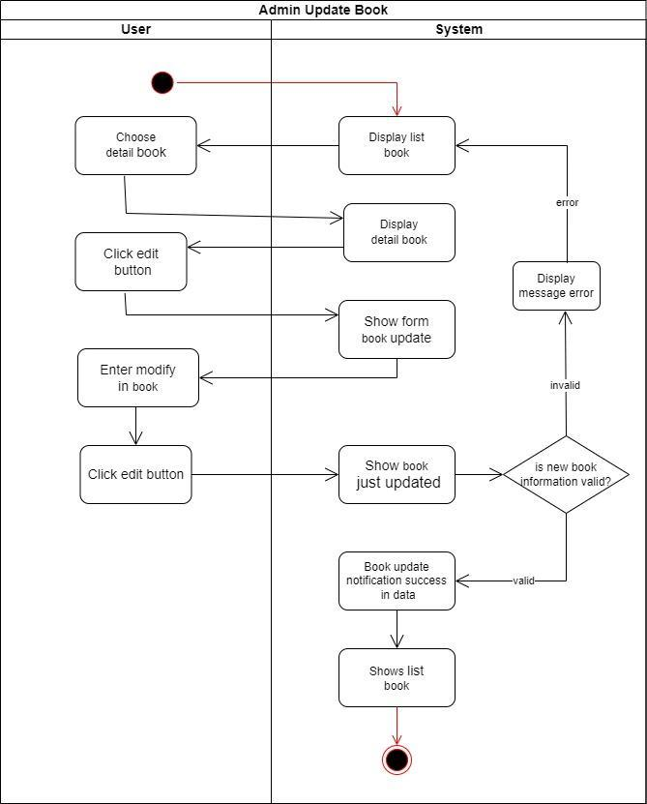

**Admin Delete Book:**

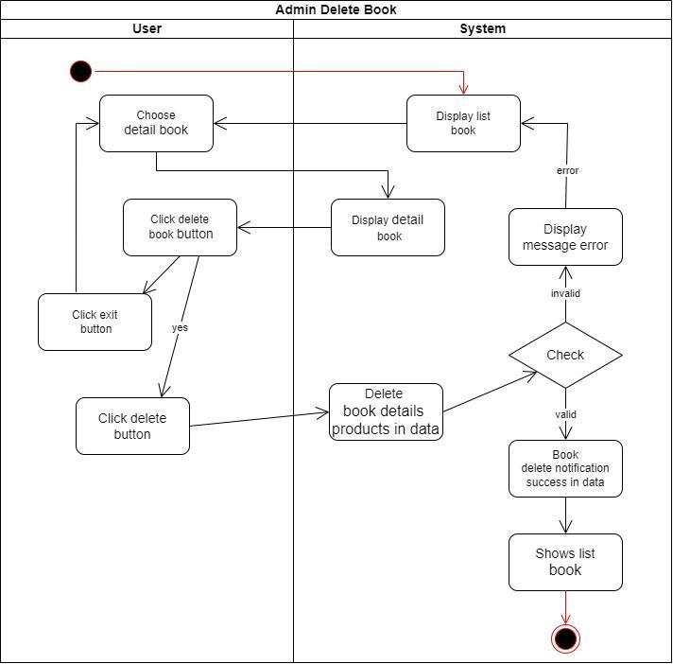

**Recipe Ice Cream From Customer:**

**Admin, Customer delete Recipe ice cream:**

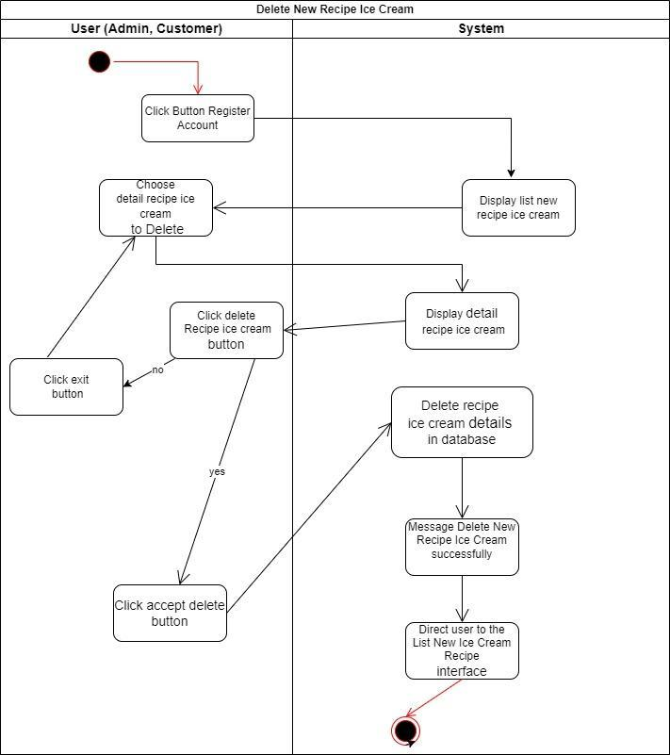

**Customer send Recipe Ice Cream:**

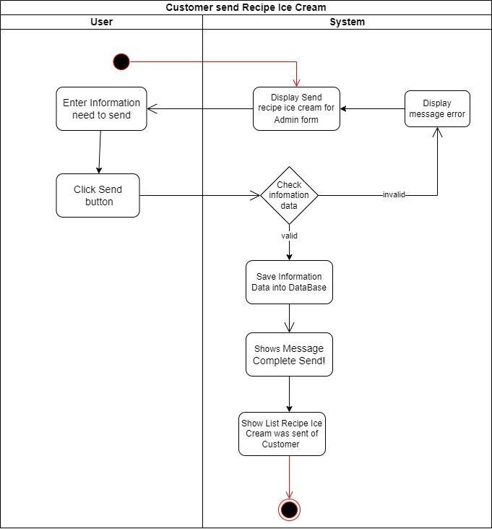

**Customer Update Recipe Ice Cream:**

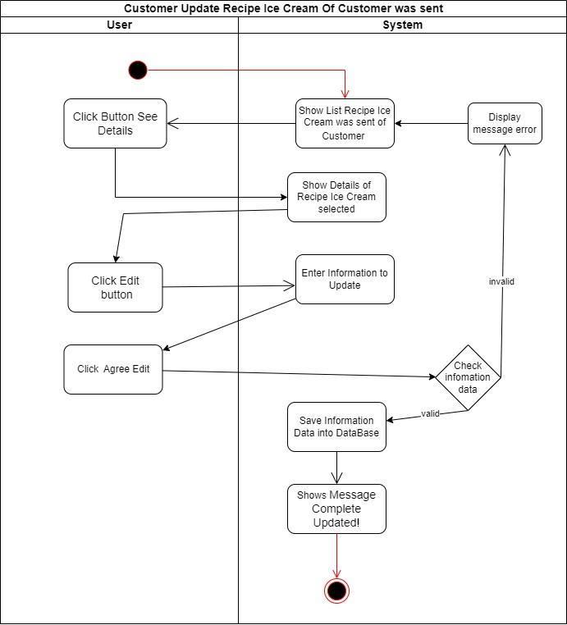

**Customer Delete Recipe Ice Cream:**

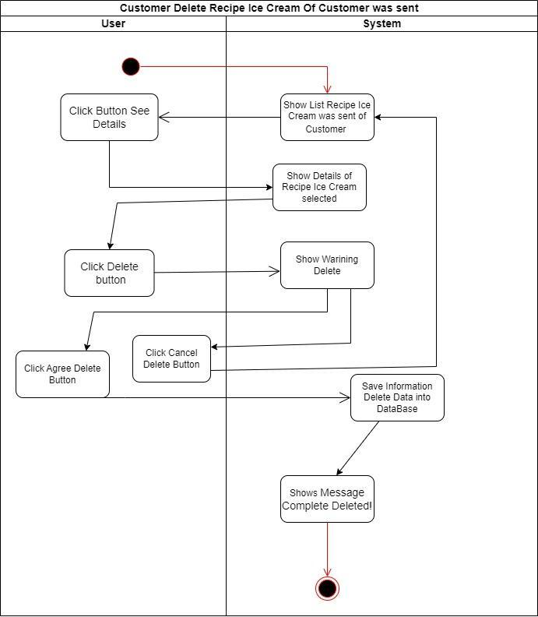

**Admin Check Recipe Ice Cream:**

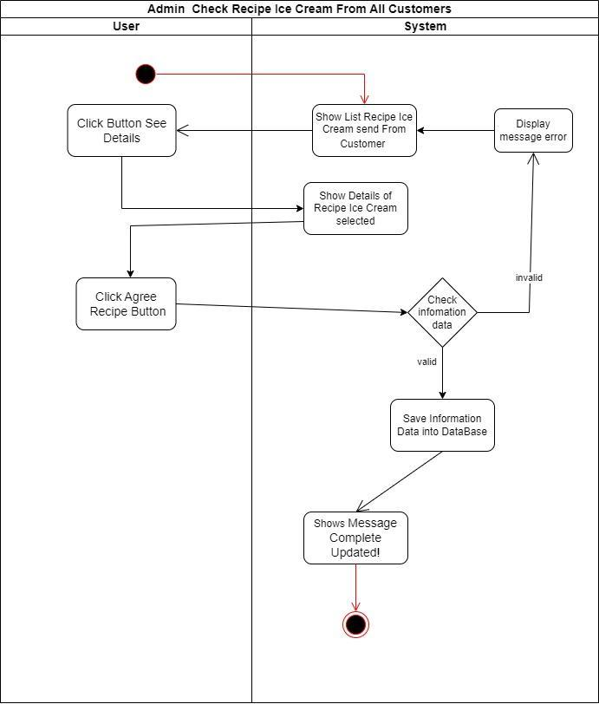 **Admin Update Recipe Ice Cream:**

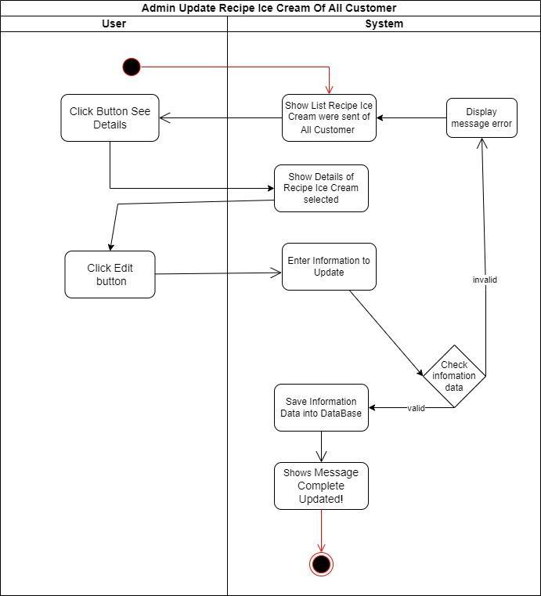

**Admin Delete Recipe Ice Cream:**

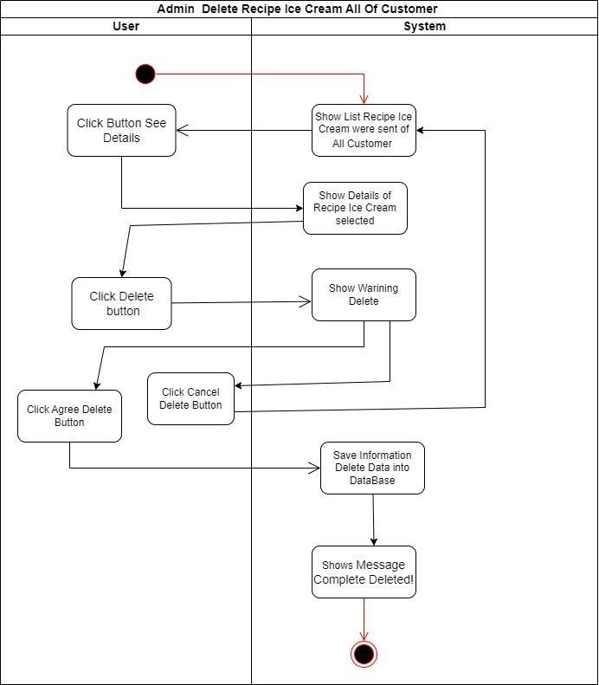

**Task Sheet**

| **Project Ref.No:** | | **Project**  **Title :** | **Activity Plan Prepared By:** | **Date of Preparation of Activity Plan:** | | | |
| --- | --- | --- | --- | --- | --- | --- | --- |
| **Sr.No.** | **Task** | **Actual Start Date** | **Actual Days** | **Team Mate**  **Names** | **Status** |
| 1 | Problem Definition |  | Đức | 21/2/2023 | 20/03/2023 | Đức | 100% |
| 2 | CRS | Anh | 21/2/2023 | 20/03/2023 | Anh | 100% |
| 3 | Use Case Diagram | Đức | 21/2/2023 | 20/03/2023 | Đức | 100% |
| 4 | Hardware and Software required for implementing the project  +site map+ timeplate+ class diagram | Khoa | 21/2/2023 | 20/03/2023 | Khoa | 100% |
| 5 | Activity Diagram | Đức | 21/2/2023 | 20/03/2023 | Đức | 100% |
| 6 | Task Sheet | Đức | 21/2/2023 | 20/03/2023 | Đức | 100% |
| 7 | Submission Checklist | Anh | 21/2/2023 | 20/03/2023 | Anh | 100% |
| 8 | USER GUIDE | Anh | 21/2/2023 | 20/03/2023 | Anh | 100% |
|  |  |  |  |  |  |  |

**Submission Checklist**

| **Sr. No.** | **Particulars** | **Yes** | **No** | **NA** | **Comments** |
| --- | --- | --- | --- | --- | --- |
| 1 | Have all the modules been properly integrated and are they completely functional? | Yes |  |  |  |
| 2 | Does each until meet its objective and purpose?  Are all the validations happening as specified in Process Design? | Yes |  |  |  |
| 3 | Have all Design and Coding standards been followed and implemented? | Yes |  |  |  |
| 4 | Is the GUI design and coding standards been followed and implemented ? | Yes |  |  |  |
| 5 | Are the codes working as per the specification ? | Yes |  |  | All the modules are property tested |
| 6 | Does the application’s functionality resolve the client problem, and satisfy his/her requirements completely? | Yes |  |  |  |
| 7 | Have the hardware and software been correctly chosen? | Yes |  |  |  |
| 8 | Additional features and utilities that give value addition to the entire project | Yes |  |  |  |

| **Option** | **Validated** |
| --- | --- |
| Do all numeric variables have a default value of Zero? | Yes |
| Does the administrator have all the rights to create and delete the records? | Yes |
| Are all the records properly fed into the appropriate database? | Yes |
| Have all the Design and Coding Standards been followed and implemented? | Yes |
| Is the GUI design consistent all over? | Yes |
| Is the navigation sequence correct through all the forms/screen in the application? | Yes |
| Is exception handling mechanism implemented in all the screens? | Yes |
| Are all the program codes wordings? | Yes |

**USER GUIDE**

1. **System Requirements:**

| **No.** | **Items** | **Description** |
| --- | --- | --- |
| 1 | Operating System | Microsoft Window 10 or higher |
| 2 | Database | SQL Server 2019 or Higher |
| 3 | Software | Visual code 2022 (with ASP.Net MVC and CORE templates) |

1. **Install and Run Application:**

**Step 1:** Install SQL Server 2019 on the local system.

**Step 2**: Create appropriate database and tables as per the specifications given.

**Step 3:** Execute the application.

**USER MANUAL**

* Customer account: (You can register a new account).
* Username:Khoa2001
* Password:Khoa2001
* Administrator account:
* Id:Adnim
* Password:123456789

Made with customer rights: (Remember to follow the direction of the arrow)

1. **Guest**

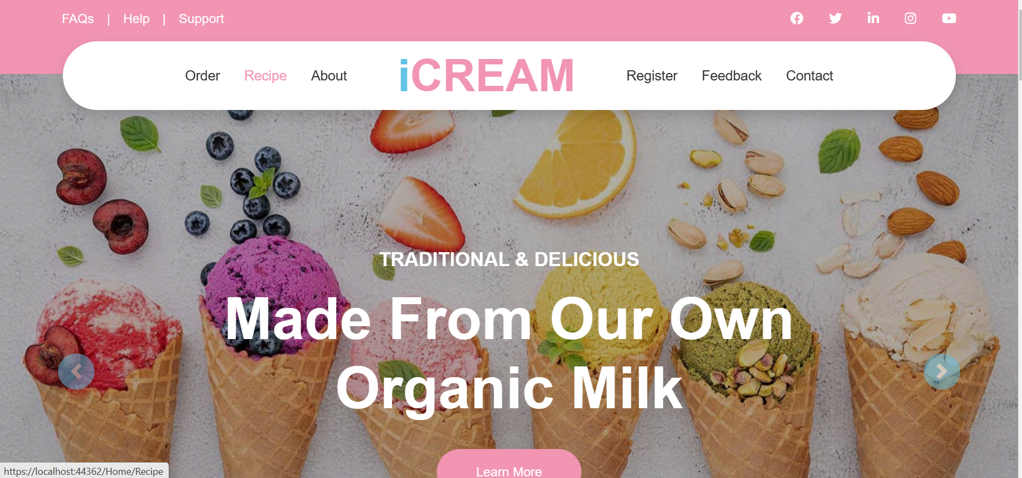

* The Ice-Cream Parlour Shop

1. **Home of Customer**

2.1. Login:

2.2. Home Page:

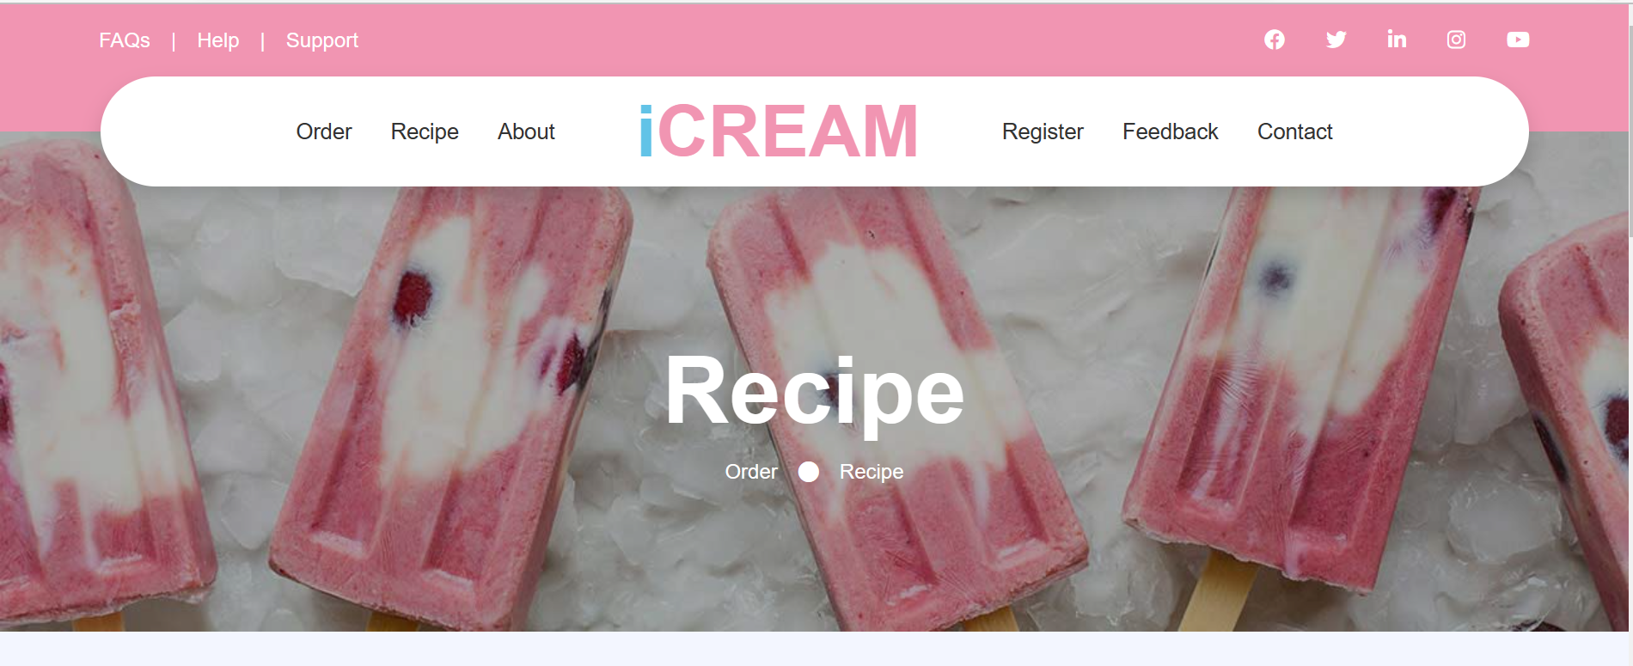

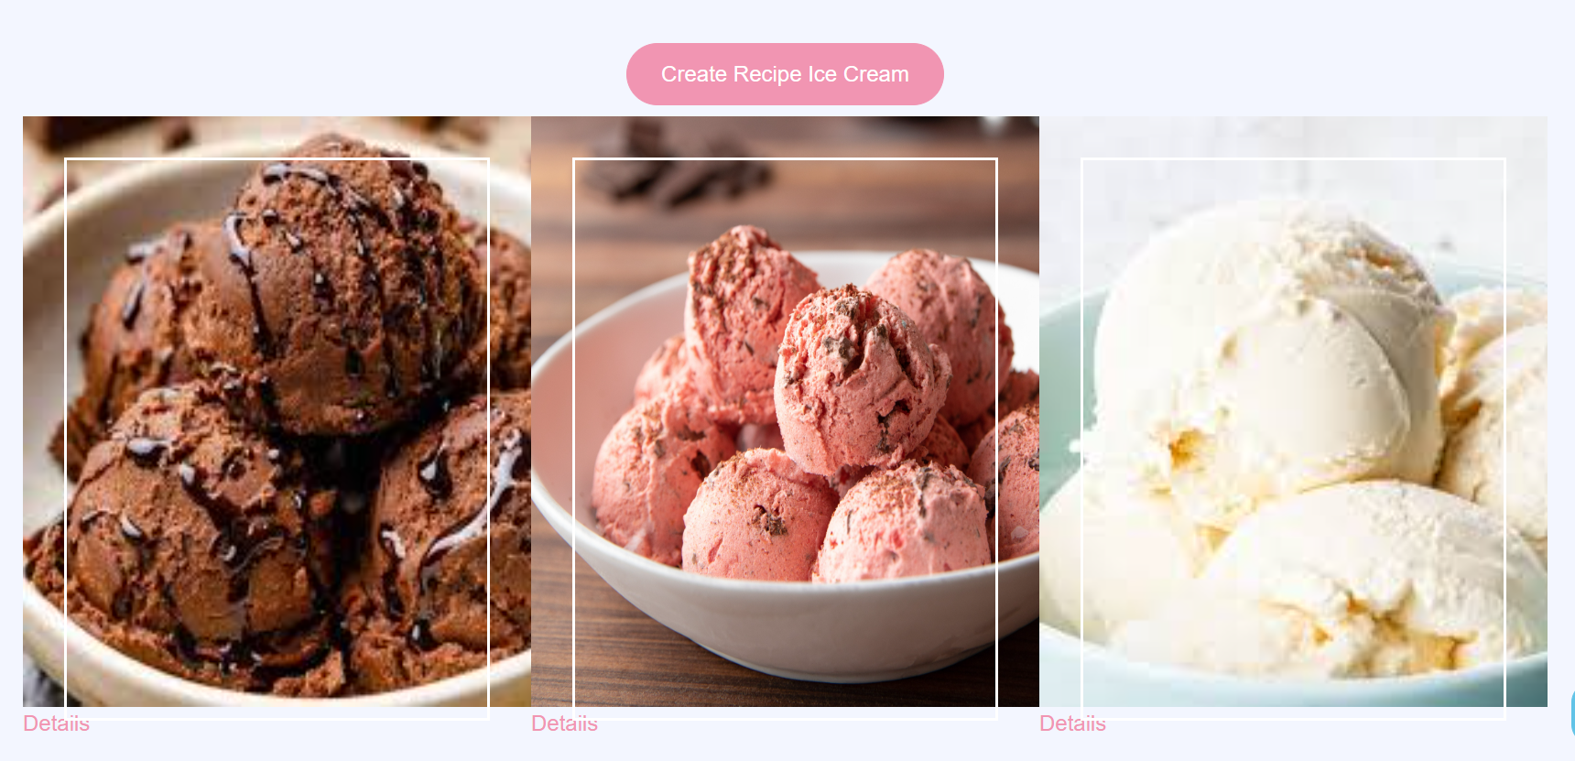

* Guests can see the ice cream recipe for free but will have limited viewing rights.
* Guests and customers can share ice cream recipes for The Ice Cream Parlor Shop. If the recipe is good, I will notify the author's copyright of the recipe and pay the commission.
* If you register as a member, you can see more ice cream recipes and will have to pay a service registration fee.

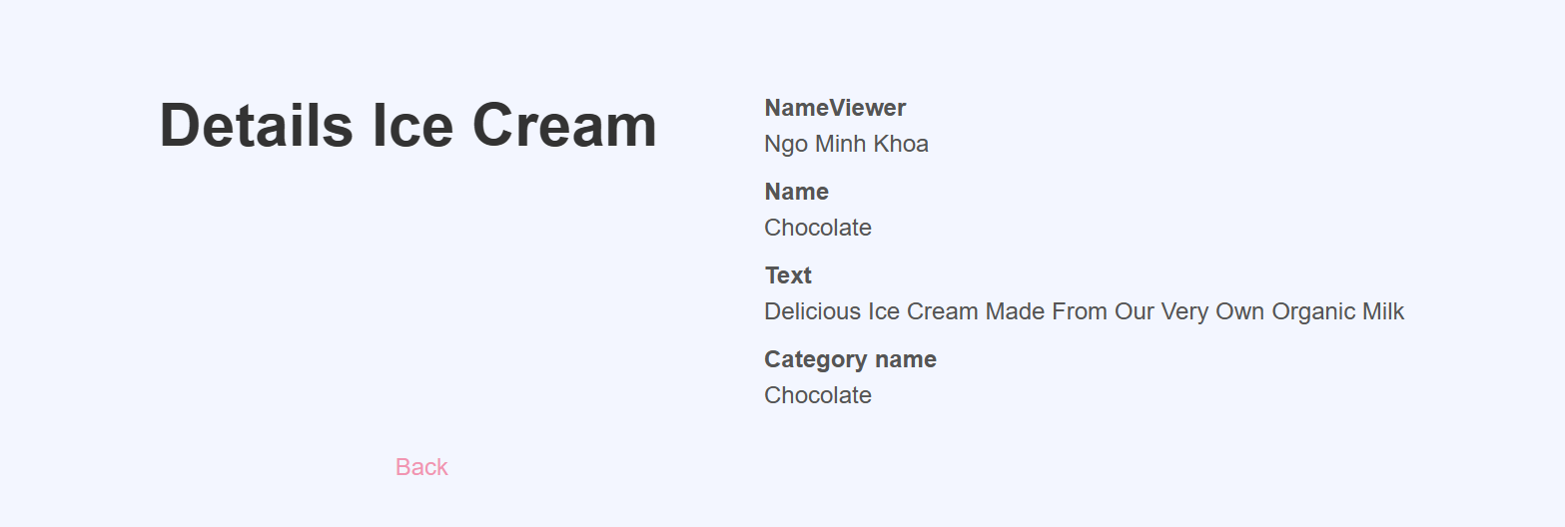

* Customers can see the details of the ice cream recipe



* Customers can see the book

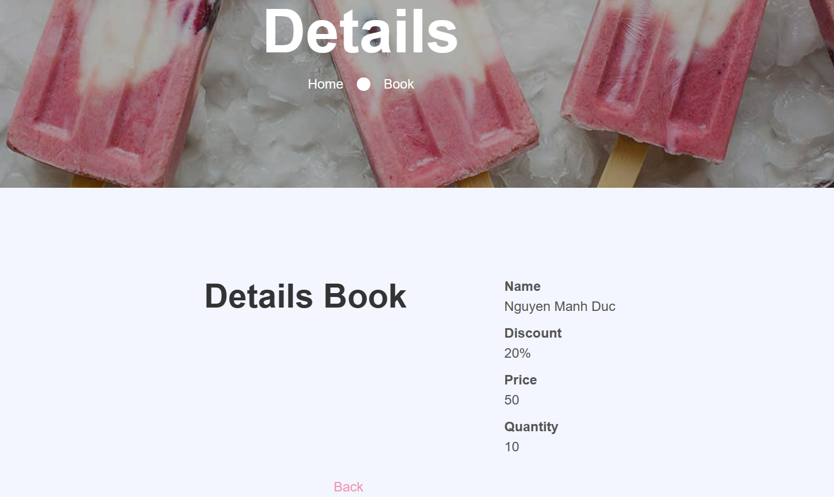

* Customers can see the details information of the book
* **About page:**

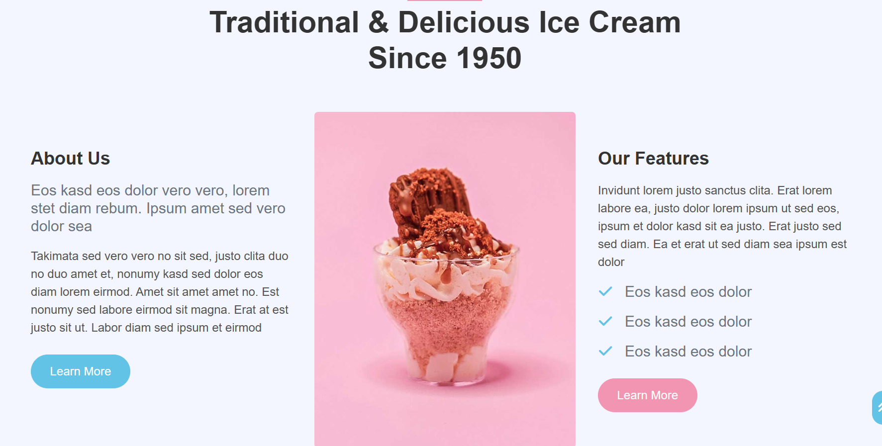

* Customers can see details information Ice Cream Parlour Page**.**

* Customers can contact Ice Cream Palour on Contact Page by Send message .

1. **Administration**

**Register:**

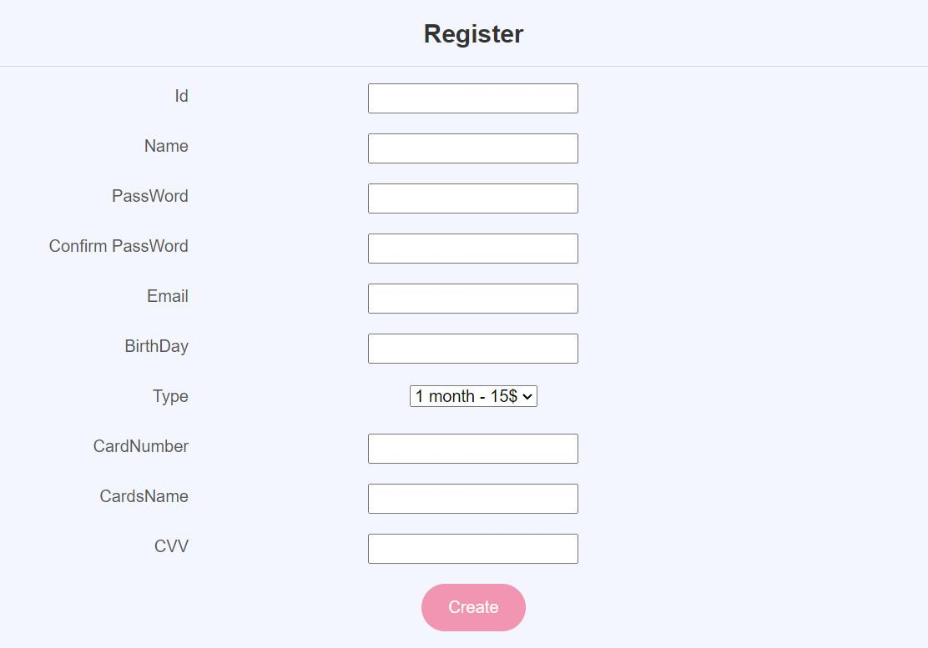

* **Login**

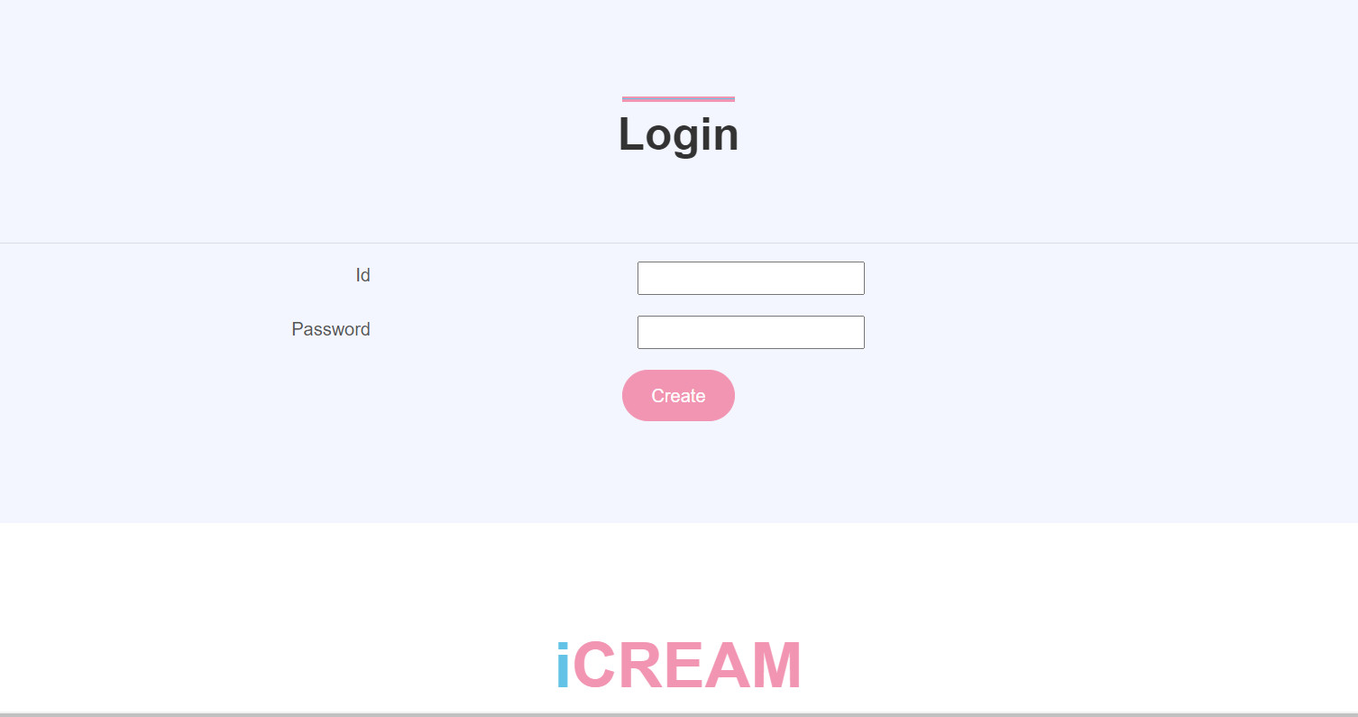

* Admin can enter information Admin Id and Admin pass on Login Page to Login into Account Manage

**3.2. Manage Customer**

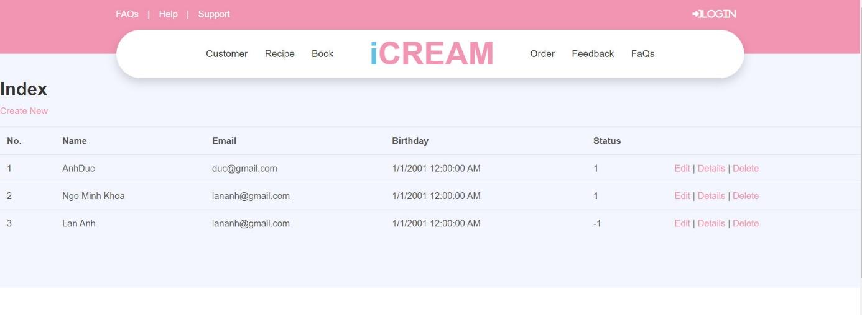

* Admin can manage Customer Account List on Customer page: Edit , Delete , See Details information Customer.

**3.3. Manage Order Book**

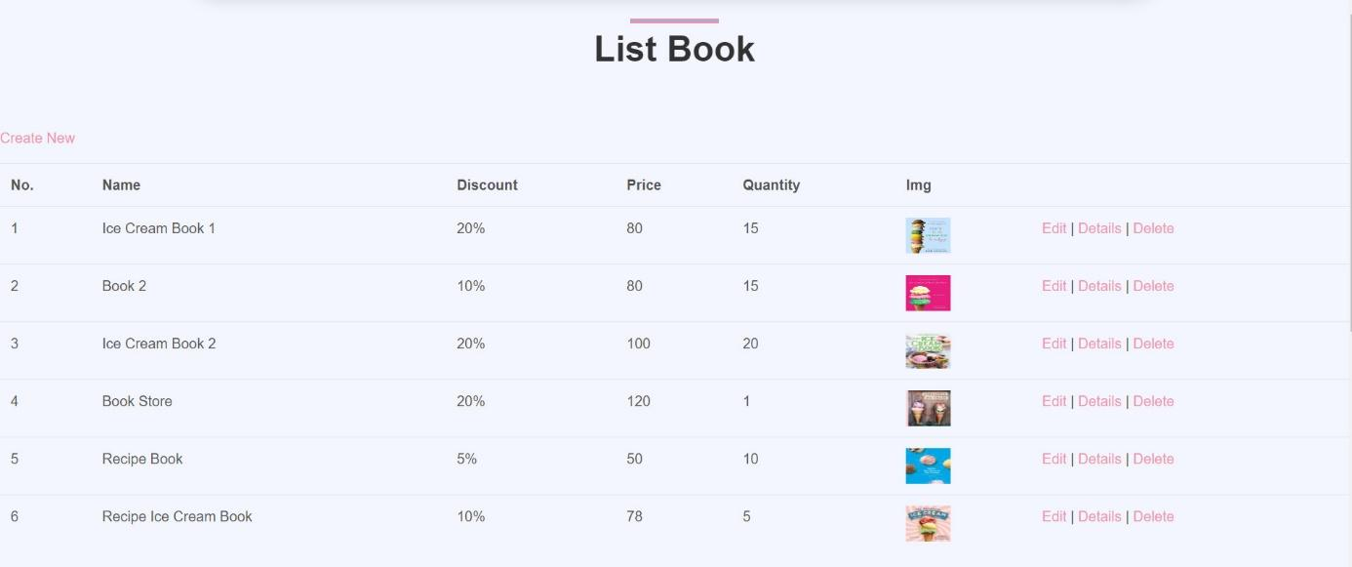

* Admin can manage Order Book List on Order Book page: Edit, Delete , See Details information Order.

**3.4. Manage Order Details**

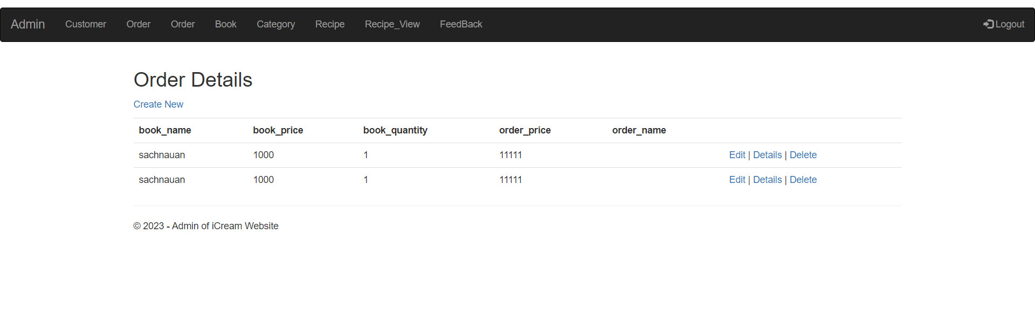

* Admin can manage Order Book List on Order details page: Edit, Delete , See Details information Order.

**3.5. Manage Book**



* Admin can manage Book List on Customer page: Edit Book, Delete Book, See Details information Book.

**3.6. Manage Recipe Ice Cream**

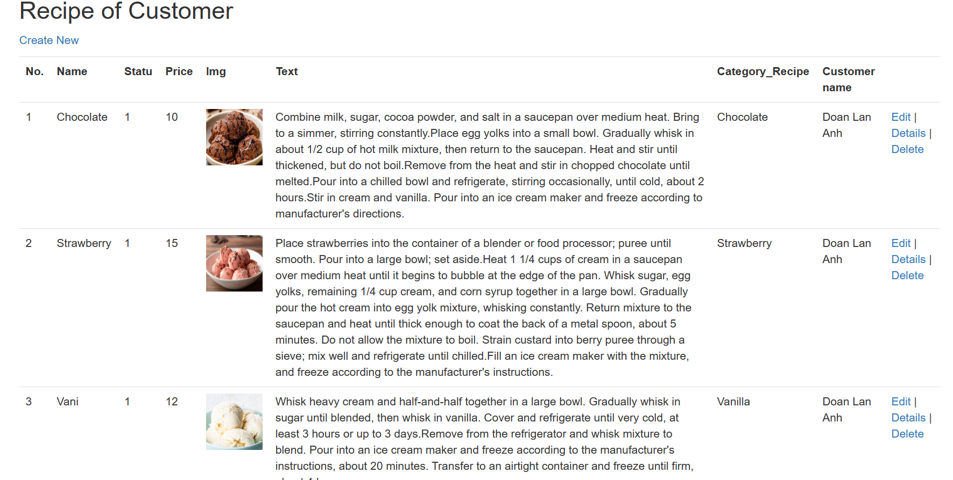

* Admin can manage Recipe Ice Cream List from Customer on Recipe of Customer page: Edit , Delete , See Details information Recipe Ice Cream from Customer

Create Recipe Ice Cream: 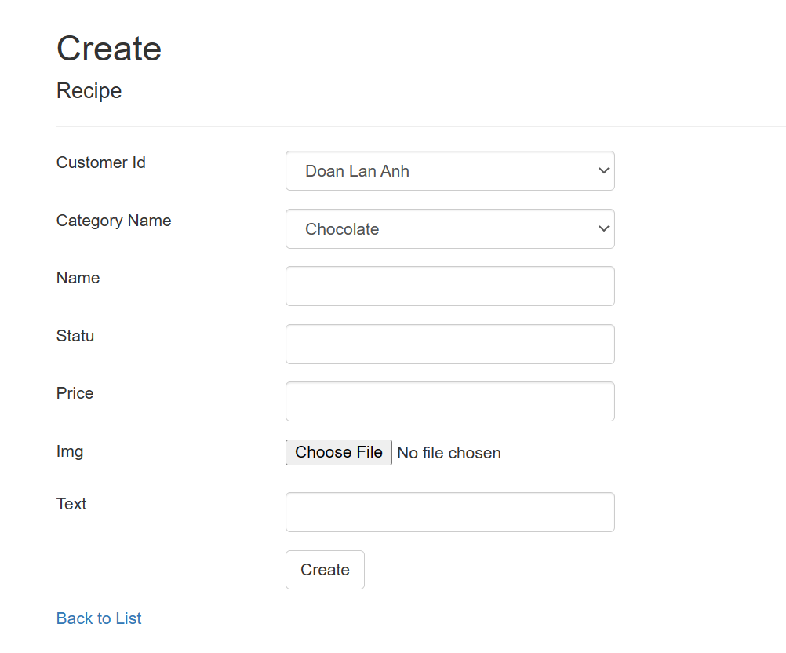

* Admin can Create Recipe Ice Cream on Recipe Ice Cream page: Edit , Delete , See Details information Recipe Ice Cream of Ice Cream Parlour
* **Edit Recipe Ice Cream:**
* 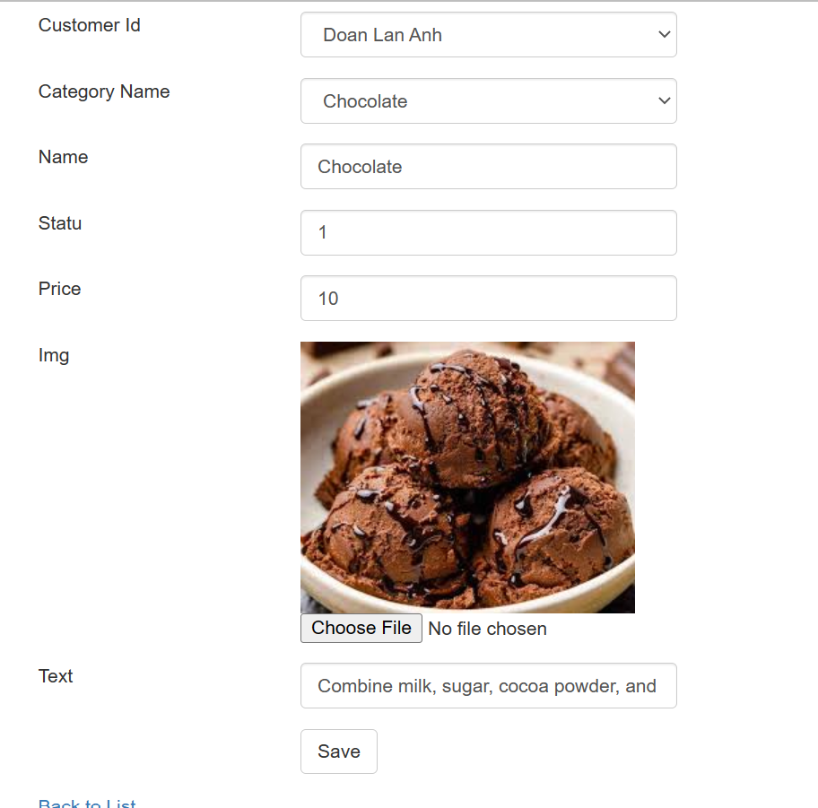
* Admin can Edit Recipe Ice Cream on Recipe Ice Cream page: see details and edit information Recipe Ice Cream of Ice Cream Parlour and click button Save to Database
* **Details**

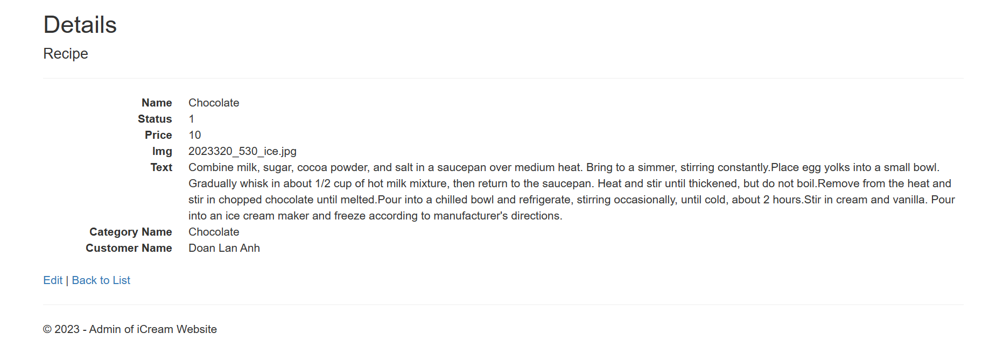

* Admin can see Details Recipe Ice Cream on Recipe Ice Cream page: see details information Recipe Ice Cream of Ice Cream Parlour.
* **Delete**

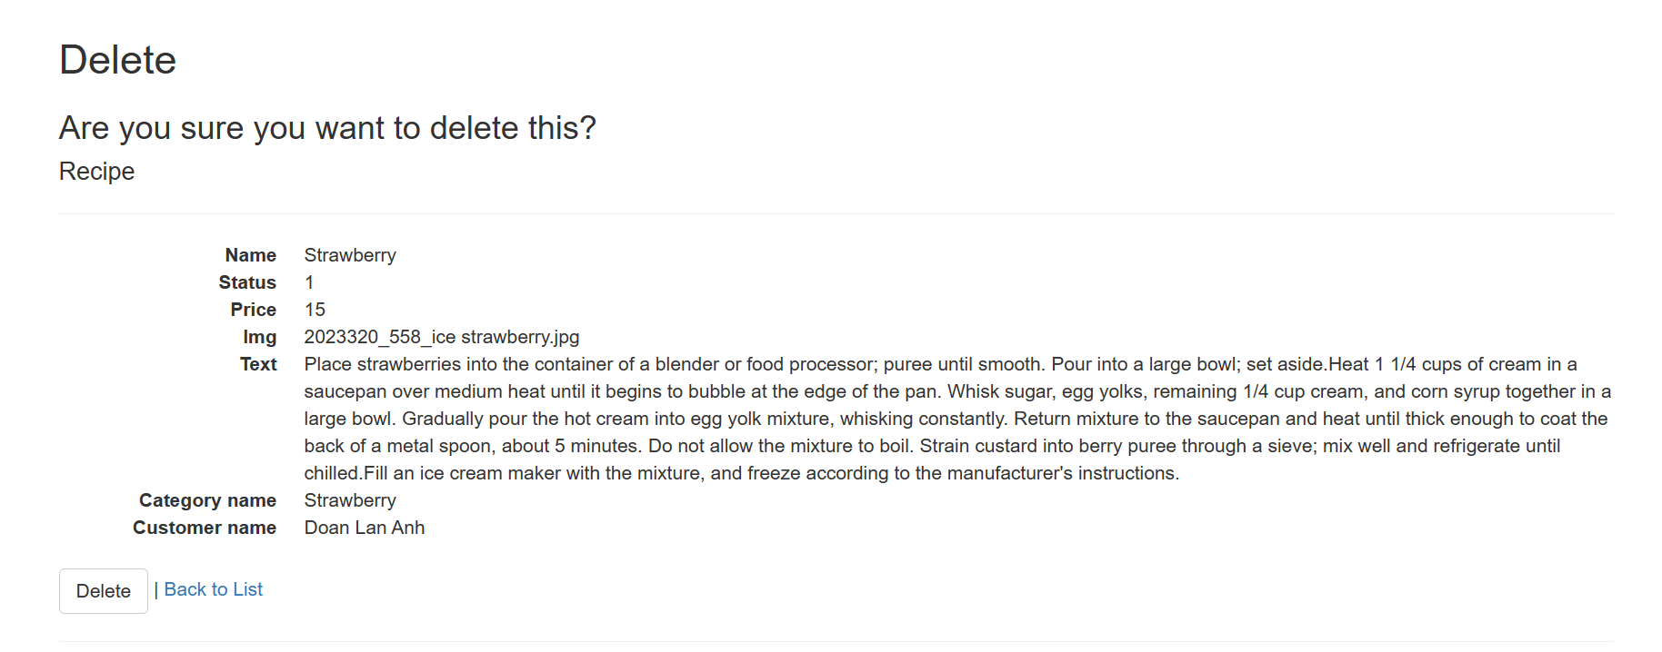

* Admin can delete Details Recipe Ice Cream on Recipe Ice Cream page: click button delete details information Recipe Ice Cream of Ice Cream Parlour.

**3.9. Manage Feedback**

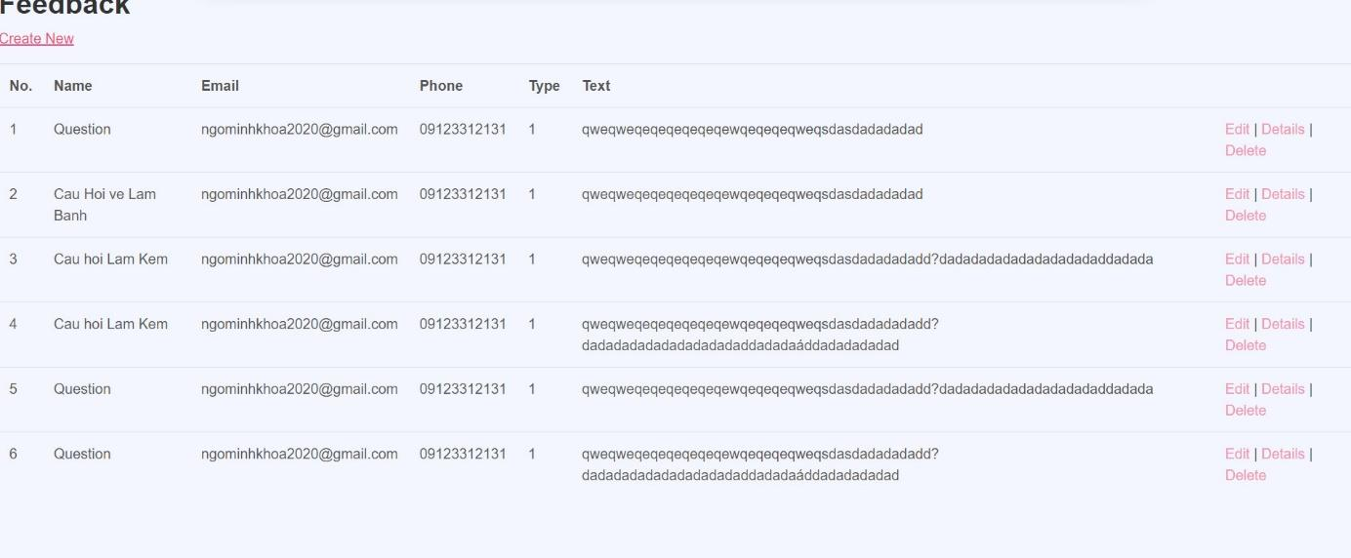

* Admin can create , edit, see Details and Delete Feedback on Feedback page: click button edit, details, delete.

Feedback

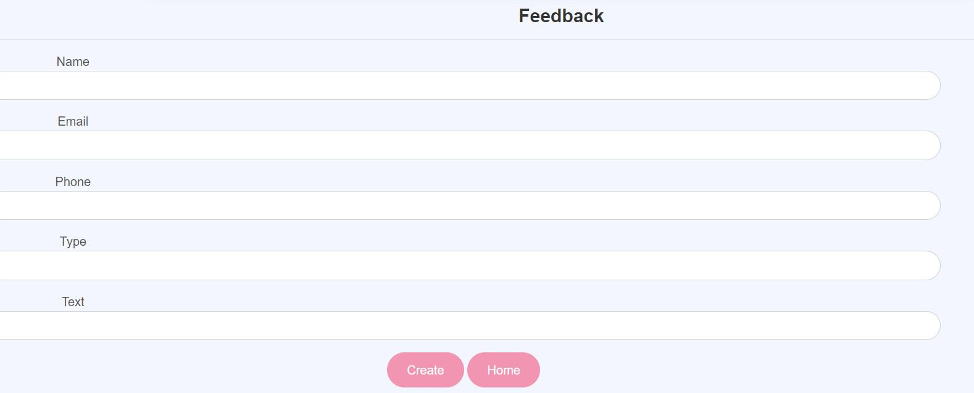

Manage book



Admin can manage, add, edit, delete data related to books

Create Book

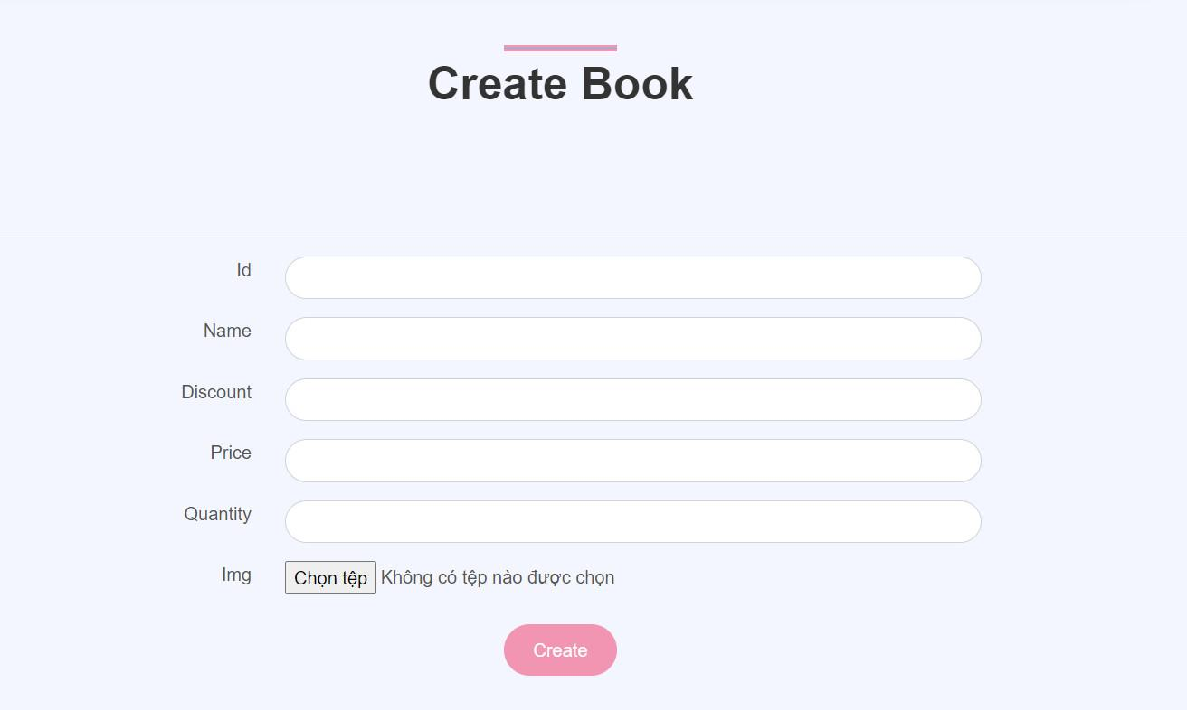

More book types and information

Edit Book

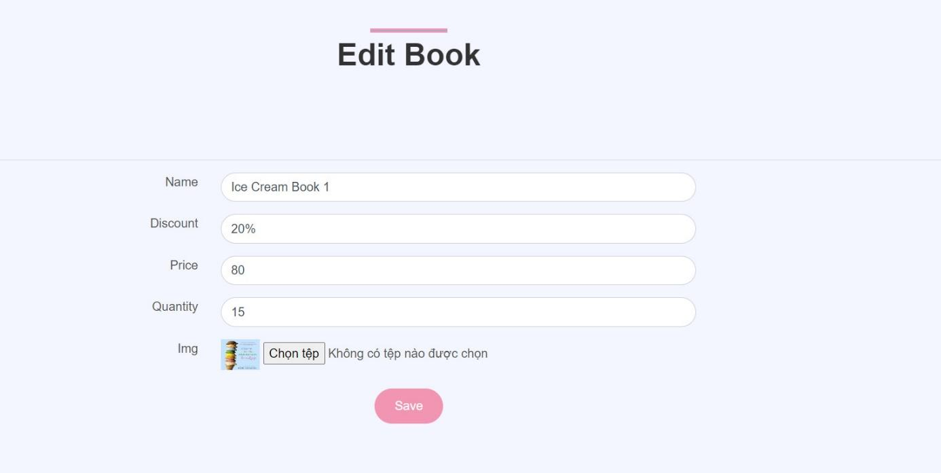

Edit the information of the book

FeedBack



Customers can create management information for managers to see

fAQ

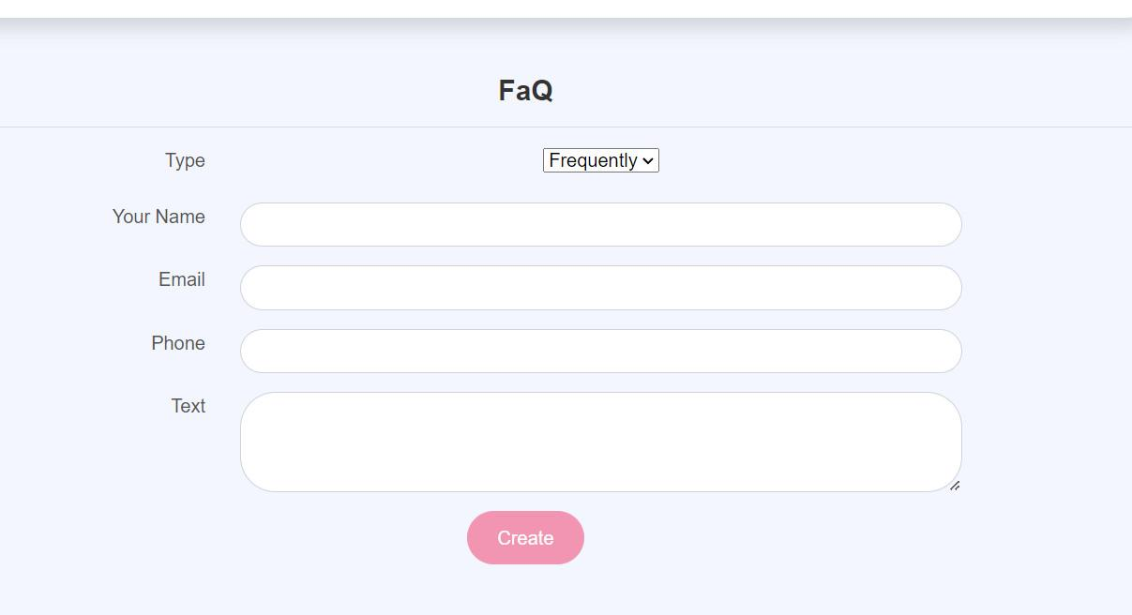

Create questions and answers about customer concerns